AquaCrop Plant Modeling

by

Caroline Schulte

____________________________

Copyright © Caroline Schulte 2021

A Report Submitted to the Faculty of the

DEPARTMENT OF BIOSYSTEMS ENGINEERING

In Partial Fulfillment of the Requirements

For the Degree of

MASTERS OF SCIENCE

In the Graduate College

THE UNIVERSITY OF ARIZONA

2021

THE UNIVERSITY OF ARIZONA

GRADUATE COLLEGE

As members of the master’s committee, we certify that we have read the thesis prepared by Caroline Claire Schulte, titled Optimal Nutrient Concentrations for Vegetative Hemp Cultivation, and recommend that it be accepted as fulfilling the dissertation requirement for the master’s degree.

_________________________________________________________________ Date: ____________

*[Dr. Peter Waller]*

_________________________________________________________________ Date: ____________

*[Dr. Kim Ogden]*

_________________________________________________________________ Date: ____________

*[Dr. Kelly Thorp]*

Final approval and acceptance of this thesis is contingent upon the candidate’s submission of the final copies of the thesis to the Graduate College.

I hereby certify that I have read this thesis prepared under my direction and recommend that it be accepted as fulfilling the master’s requirement.

_________________________________________________________________ Date: ____________

*[Dr. Peter Waller]*

Master’s Thesis Committee Chair

*[Biosystems Engineering]*

# Acknowledgments

I would first like to thank my thesis committee - Dr. Peter Waller (my major advisor), Dr. Kim Ogden, and Dr. Kelly Thorp - for their mentorship. I would also like to thank Hadiqa Maqsood for her guidance and assistance throughout my masters.

I would also like to extend gratitude to my advisor - Dava Jondall - and the Biosystems Engineering department head - Dr. Kitt Ferrell-Poe - for their continuous support and encouragement throughout my time at the University of Arizona.

Lastly, I would like to thank my parents - David and Luitgard Schulte - and my sister - Jessica Schulte - for their ceaseless love and belief in me.

# Table of Contents

**Acknowledgments**3

**Table of Contents**4

**Abstract**5

**Introduction**6

**Literature Review**7

Guar 7

SBAR 8

Plant Modeling 9

AquaCrop 10

**Methodology**13

**Calibrations**15

Weather 16

Soil 17

Soil Parameters 17

Guar Soil Calibrations 19

Crop 25

Crop Parameters 25

GDD Calculations 32

Fshape Parameters 33

Guar Crop Calibrations 34

Field Management 41

Field Management Parameters 42

Guar Field Management Calibrations 42

Groundwater 43

Groundwater Parameters 43

Guar Groundwater Calibration 44

**Code**44

Main Code 44

Outputs 45

**Results and Discussion**46

**Summary and Recommendations**48

**References**50

**List of Figures**57

**List of Reference Tables**66

# Abstract

The United Nations predicts that by 2050 the population will have increased by 2 billion people. Additionally, Earth’s global temperature is predicted to continue rising mainly due to human activity producing greenhouse gasses. The greenhouse gasses produced by such a population will cause the Earth’s temperature to rise between 2.5 and 10 0F over the next 100 years (“The Effects of Climate Change,” n.d.). In conjunction with this temperature spike, resources such as water and food will gradually become scarcer. Consequently, there is a rapidly growing need for improvement in efficiency of agricultural systems. However, the process of running field trials can be expensive, time-consuming, and profligate. Plant simulation models are an inexpensive, useful resource that can be used to predict how physical, chemical, and biological environmental constraints will influence cultivation of crops given a specific region. This report not only delves into analyses of various modeling options, but ultimately summarizes how AquaCrop-OSPy (a modeling program executed in Python) can be calibrated to represent horticulture. To exemplify the capabilities of this program and show how to think through the calibration process, a guar experimental calibration was commenced in this report (to be continued by partnering colleagues). Calibrations of this program can assist farmers in making informed management decisions on irrigation techniques, crop selection, planting and harvesting dates, and environmental conditions (soil type, and canopy density) for maximum profitability and resource use.

*Keywords:* Guar (*Cyamopsis tetragonoloba* (L.)), AquaCrop, AquaCrop-OSPY

# Introduction

Crop models are defined as “a quantitative scheme for predicting the growth, development, and yield of a crop, given a set of genetic features and relevant environmental variables (Steduto, 2009).” They are mainly used as agronomic research tools to inexpensively test combinations of inputs on crop cultivations, or for management optimization purposes regarding planting and harvesting dates, crop selection, or irrigation schedules. This report acts as a manual describing how to calibrate the AquaCrop Python model (AquaCrop-OSPy). As an example, the AquaCrop-OSPy was calibrated to represent experimental growth of guar conducted by SBAR. The guar experiment used for the example calibration in this report was conducted in 2018 in Clovis, New Mexico. This study analyzed the effects on yield and phenology (Singh, 2020). The crop and soil parameters were calibrated in the AquaCrop-OSPy model according to data from this experiment and the knowledge of experts. While this calibration did not result in outcomes corresponding to the experimental outcomes, it is meant as a guide for future researchers on how to think through the calibration process. It can also be used as a basis for future SBAR students to manipulate and practice calibrations until the actual experimental outputs are obtained. Then, the program can be used to predict future crop yields, and test various experimental parameters for guar.

# Literature Review

## Guar

Guar is a drought resistant legume (member of the pea family) that is used as feed for both humans and cattle, and a key tool in industrial applications. Mature guar seeds have endosperm containing an abundance of a polysaccharide known as galactomannan. This gum has an abundance of industrial applications from natural gas extraction to a digestive aid. Some of the industries it is used in include explosives, petroleum, textiles, paper, ore-refining / metal, coalmining, food, pharmaceutical and cosmetic, and agriculture (Kuravadi, 2013).

Typically, guar is grown in the dry regions of India and Pakistan. India ranks number one in this industry, producing 80% of the world’s total guar gum. However, it is also grown in the United States, China, Germany, Russia, and Italy. It originally came to the USA in 1903 to test if it was adaptable to the hot and dry southwest region. The USA then began competing in this industry during World War II. Originally, carob seeds were imported to the United States for extraction of their gum. Yet, this supply was cut off during World War II due to a blockage on imports. Thus, guar began to be cultivated as an alternative gum producing crop for the paper industry. Since then, it has been adapted to the many industries listed previously (Kuravadi, 2013). Currently, it is usually grown in Arizona, New Mexico, Texas, and Oklahoma (Kiela, 2018).

Guar is not only highly adaptable commercially, but it also improves soil health and is relatively inexpensive to grow (Kiela, 2018). To explain, guar has been found to increase the Nitrogen reserve levels in soils. This leads to increasing yields in crops grown later in the same fields. For example, a study conducted in Texas used guar in rotation with cotton. The experiment found a 15% increase in yield of cotton following the guar growth (Undersander, 2020). Additionally, fixing the nitrogen in the soil decreases the necessity for herbicides and fertilizers needed in future crop cultivation (“Our Story,” 2020).

## SBAR

SBAR stands for Sustainable Bioeconomy for Arid Regions. In collaboration with the USDA National Institute of Food and Agriculture (NIFA) and the Center of Excellence research team, their vision is “to provide stakeholders, interested in expanding crop options that support the rubber and biofuel in industries, with regional solutions that are economically viable, socially acceptable, and meet the water conservations needs of the arid Southwest (AZ,CA,NM, and TX) (“Our Story,” 2020).” Their focus is on two different crops - guar and guayule. Different genotypes of these crops taken from the USDA National Plant Germplasm System are being studied for superiority. Specifically, guar is being grown in Tucson, Arizona; Las Cruces, New Mexico; and Clovis, New Mexico.

The guar experiments are centered around maximizing biomass quantity and quality by measuring yield resulting from varying planting density and irrigation trials (or moisture stress) (Rogstad, 2020). In Clovis, the effects of full irrigation versus limited irrigation were tested from 2018-2020. The limited irrigation was supplied during the pre-planting, vegetative, and reproductive stages. By evaluating soil moisture, yield, and biomass, the experiment in 2018 showed that guar can tolerate extremely low levels of water (“Feedstock Development and Production*”*, 2020). This conclusion was used as the foundation for calibrating the AquaCrop-OSPy model in this report.

## Plant Modeling

There are an abundance of plant modeling programs available. In general, these models can be categorized into two main categories - the engineering models and the scientific models. The scientific models focus on plant morphology and how it may respond to changes in its environment. On the other hand, engineering models focus on assisting users with management decisions.

Many of the available engineering-based crop modeling programs tend to be extremely complex and require extensive knowledge in commercial farming for proper utilization. These include the EPIC model, its derivation ALMANAC, CropSyst, DSSSAT, the Wageningen models, and the APSIM models. Each of these models can assist in management decisions and are oriented towards large scale agriculture, yet require advanced training (Steduto, 2009). Three of the freely available and simplified engineering-based crop models are known as CropWat, AquaCrop, and SWBM. AquaCrop and CropWat were both developed by the FAO (the Food and Agriculture Organization), with AquaCrop being an evolution of CropWat. SWBM (Soil Water Balance Model) was developed by NAFRI (National Agriculture and Forestry Research Institute of Laos), UQ (University of Queensland), and IRRI (International Rice Research Institute). All three of these models require minimal input data but do require the data to be in specific formats prior to execution.

Out of the three more basic engineering-based models, AquaCrop has been identified as the superior model. This is because it can account for rising atmospheric CO2 concentrations and increasing surface temperatures, it is relatively insensitive to soil nutrient status variability which enables comparisons of water-limited productivity across various regions, crops, and seasons, it allows users more flexibility in defining multiple soil profile layers, canopy cover (CC) is used to show foliage development rather than leaf area index (LAI) which simplifies the program greatly as CC values can be easily estimated by the human eye or from satellite data unlike LAI, and it has been widely adopted within the global scientific community (Vote, 2015).

## AquaCrop

AquaCrop is a windows-based program that was originally developed as a tool to simulate crop yields in environments with limited water availability (Steduto, 2009). This is done by calculating the interactions between the crop(s) and soil(s). Practically, it can be used in a variety of situations; it can be used as an educational tool exemplifying how crops respond to environmental conditions, to predict yields given various combinations of inputs, as a benchmarking tool to identify possible yield constraints, as a planning tool to develop irrigation and management strategies, or as a scientific tool to predict how climate change may affect the agricultural industry (“Food and Agriculture,” 2017). The target audience is thus extremely broad, including agronomists, economists, teachers, engineers, farmers, governmental agencies, extension services, scientists, policy makers, and water managers (Vote, 2015). Since its first release in January of 2009 (version 3.0) by the FAO, it has been continually enhanced leading to the most current version (version 6.1).

The AquaCrop program requires environmental condition inputs to output predicted biomass and crop yields. Figure 1 displays the inputs and outputs associated with the model. The inputs include characteristics of the atmosphere, plant, and soil along with management practices. With regards to the atmosphere, daily, 10-daily, or monthly reference evapotranspiration, and minimum and maximum air temperatures are required along with daily rainfall data and mean annual CO2 concentrations. For crop specification, planting and harvesting dates, plant density, maximum canopy cover, time it takes for a crop to emerge, flower, start canopy senescence, and reach maturity, the harvest index, maximum rooting depth, and how long it takes to reach maximum rooting depth are the required inputs. For soil customization, users can customize the hydraulic properties for up to five soil horizons (“Food and Agriculture,” 2016). These customizations include field capacity (FC), permanent wilting point (PWP), drainage coefficient (𝛕), and the hydraulic conductivity at saturation (Ksat) (Steduto, 2009). Groundwater is also considered in soil inputs, requiring its depth in meters below the soil surface and its salinity (“Food and Agriculture,” 2017).

The management practices that are taken into consideration are the field and irrigation practices. Field management practices include soil fertility and any practice that can influence soil evaporation or runoff such as soil mulches or bunds. The irrigation management practices include the irrigation method, application depth and time of irrigation, and the salinity of the irrigation solution. Initial conditions of the soil water content and soil salinity are also required, along with field data such as crop canopy coverage throughout the growth cycle, and final yield at crop maturity (“Food and Agriculture,” 2016). Unfortunately, the model does have some limitations. It is only able to simulate crops within one growth cycle in a uniform field, and only vertical incoming and outgoing water is taken into consideration (“AquaCrop,” 2020).

How AquaCrop calculates yield can be seen in figure 2. In the figure, it is apparent that the soil-water balance is the main factor affecting outputs. Essentially, water in the root zone is influenced by the incoming rainfall and irrigation, and outgoing evapotranspiration, runoff, and percolation (how fast water moves through the soil). Then, how much water is lost in the root zone allows for calculation of the water stress coefficient Ks. This coefficient is highly influential as it determines the transpiration rate of the crop, which consequently affects growth and yield (Raes, 2009). Specifically, biomass (B) is a function of water productivity (WP) and transpiration (Tr), and yield is a product of the harvest index (HI) and biomass (Vote, 2015). Thus, the program depends greatly on Ks.

EQ 1

EQ 2

The AquaCrop model is widely used in industry around the world for a variety of crops. One example of its application comes from an experiment with barley conducted in Ethiopia. Ethiopia has an extensive drought predicament meaning the cheap, drought resistant crop barley - used for both animal feed and human consumption - is highly popular. With scarce and unpredictable rainfall, an experiment was conducted to assist farmers in successfully cultivating this important crop. AquaCrop was proven able to optimize harvests and decrease food insecurity through determining optimal planting times and irrigation techniques given water constraints (Araya, 2010). On a different note, AquaCrop was used to determine ideal maize sowing management options in Zimbabwe. The model was calibrated to fit Zimbabwe’s low soil fertility levels, along with the expected climate in different regions. From this successful calibration, researchers were able to generate a table that agriculturists could use to select ideal sowing dates given their region’s climate and soil depth (Mhizha, 2014). Additionally, AquaCrop was shown to accurately predict increased maize production given biochar and inorganic fertilizer in Nigeria (Faloye, 2020). These are just three successful examples of how instrumental this model has been in the agricultural industry.

# Methodology

The program calibration was conducted by altering an AquaCrop-OSPy module and testing the calibration in a sample program. AquaCrop-OSPy is an open source code in Python, meaning it is freely available to the public. The OSPy version is based on the original, standard windows program (discussed in the literature review “AquaCrop” section of this report) created by the Land and Water Division of the FAO. It is a commercially used crop growth modeling program. While it is available in both Matlab and Python, the focus of this report is only on the Python version for collaboration with other students and to establish a basic understanding of this model for future use by SBAR. Additionally, the open source version is far more customizable than the original model is (“AquaCrop”, 2020).

The reason AquaCrop-OSPy is more customizable than its original windows version is because it is given in an open source format. One of the largest shortcomings of the AquaCrop computer model is that it is constrained to its application. This prevents users from altering the output to highlight specific components. Plus, using an application prevents users from altering or replicating the calculations to apply the model’s simulations in other programs (Foster, 2017). Converting AquaCrop to an open source code in Python grants users access to the inner workings of the model. Specifically, the Python version uses the module aquacrop.classes to specify the input characteristics for climate, crop, soil, and irrigation treatments (see figure 1). Thus, AquaCrop-OSPy can be calibrated to model a crop’s growth by customizing the parameters to match crop characteristics and its environment (“AquaCrop”, 2020). Overall, the open source access allows users to alter the model or copy and merge the model with other models for user specific purposes (Foster, 2017).

The AquaCrop-OSPy version being calibrated was retrieved from the Python package index website (<https://pypi.org/project/aquacrop/>) in Spyder and was released on January 5, 2021 (version 0.1.4). It is important to note that this program is still in its developing stages, meaning the sample guar calibration and this manual will need to be updated as the OSPy version of AquaCrop is developed. The OSPy program has been pre-calibrated for the crops maize, wheat, potato, and rice. It also contains parameters for the soil types: tunis local, paddy, silt clay, silt loam, silt clay loam, silt, sandy loam, sandy clay loam, sandy clay, san loamy sand, loam, clay loam, and clay. These pre-programmed components were used to guide the calibrations for this report along with the user manuals for the Windows AquaCrop application.

For purposes of this report, the program was run in Spyder using Anaconda. The AquaCrop-OSPy program itself was downloaded using the Anaconda prompt. The steps to download AquaCrop-OSPy are as follows:

1. Download Anaconda from [Anaconda | Individual Edition](https://www.anaconda.com/products/individual)
2. Install Anaconda
3. Once installed, open the *Anaconda Prompt* application
4. Type ‘pip install AquaCrop’into the Anaconda Prompt
5. Hit enter

Once the program is installed, the zip file from GitHub (<https://github.com/cschulte7/Guar-AquaCrop-Calibrations>) must be downloaded and extracted. The Python file *classes_Guar.py* must be moved to the previously downloaded *aquacrop* file on your computer. Then, the final simulation model for this report (*Guar_Final.py*) can be opened in Spyder. It is important to note that if a future version of AquaCrop - OSPy model (not version 0.1.4) is being used, this code is unlikely to run. The zip file from GitHub contains the 0.1.4 version files used to run this program. To use AquaCrop-OSPy on your computer, follow these instructions:

1. Open the *anaconda3* folder on your computer
2. Open the *Lib* folder
3. Open the *site-packages* folder
4. Open the *aquacrop* folder
5. Copy and paste the *classes_Guar.py* file into the main *aquacrop* folder
   1. If the version of AquaCrop downloaded is not the 0.1.4 version, it is best to copy all the files and folders from the *aquacrop.zip* file on GitHub into this folder and replace the existing ones to ensure the model program *Guar_Final* can run.
6. Open the *Spyder* application
7. Go to File -> Open -> *Guar_Final.py*
8. Hit run file (the green arrow at the top left corner of Spyder)

# Calibrations

To calibrate the AquaCrop-OSPy model, weather data had to be read into the program and the *classes* module’s parameters had to be altered to fit the experimental characteristics used. Within this module, the classes of soil, crop, field management, and groundwater were altered to represent the specific crops and experimental characteristics.

## Weather

When it came to weather input, the information had to be converted into a format that was compatible with the program. To do this, I put the weather data for each year into an excel file with the headers being day, month, year, Tmin(C), Tmax(C), pcrp(mm), and ET0(mm), where Tmin and Tmax are the maximum and minimum temperatures of each day in degrees Celsius, prcp is the precipitation, and ET0 is the reference evapotranspiration. This file is titled *GuarWeather_Clovis_2018* and can be found in the zip file on GitHub. There is also a *weather_template* file in this folder that can be used to input individualized data. Once the weather data in the excel file has been updated, it must be saved as a .csv file. It is important to note that this file must be in the same folder as the main simulation Python file. For example, the folder on GitHub is titled *AquaCrop_Python* and contains my main simulation Python file (*Guar_Final)* and the weather files. Once these steps have been taken, the weather file can be used in the main simulation model through the following line of code:

weather18 = pd.read_csv('GuarWeather_Clovis_2018.csv')

The succeeding line then converts the weather data to a text file with ten spaces between each value allowing the program to read the data barring any errors:

with open('GuarWeather_Clovis_2018.txt', 'w') as f: weather18.to_string(f, col_space = 10, index=False, justify = 'left')

## Soil

### Soil Parameters

The soil class contains parameters and variables of the soils to be used in the simulation. The program includes various pre-programmed soils being clay, clay loam, loam, loamy sand, sand, sandy clay, sandy clay loam, sandy loam, silt, silt clay loam, silt loam, silt clay, paddy, and ac_tunis local. However, these contain default characteristics that should be checked prior to use. In appendix B of Kelly Thomas’ notebook on AquaCrop-OSPy modelling, the parameters that can be specified for each soil class are listed as follows in table 1.

When customizing soil classes, each layers’ hydraulic properties are specified using the .add_layer function:

add_layer(thickness, thWP, thFC, thS, Ksat, penetrability)

Each of the components of this function are specified in table 2. If all the layers are meant to have the same properties, then the thickness used is (sum(dz)). For example, for the pre-calibrated soil class *clay*, all the layer properties were equal, so the following line of code was used in the *classes* module:

self.add_layer(sum(dz), 0.39, 0.54, 0.55, 35, 100)

On the other hand, if the soil layers do not have the same properties, then the thickness must be specified for each layer. For instance, for the pre-calibrated soil class *paddy,* there are two different soil layer characteristics. The first layer is 0.5 m and the second is 1.5 m. The characteristics are shown below:

self.add_layer(0.5, 0.32, 0.50, 0.54, 15, 100)

self.add_layer(1.5, 0.39, 0.54, 0.55, 2, 100)

**Table 1**

***Soil Classes Customization Parameters***

|  |  |  |
| --- | --- | --- |
| **Variable Name** | **Description** | **Default** |
| soilType | Soil classification e.g. 'sandy_loam.' There is no default for this variable as it must be specified by the user. | REQUIRED |
| CN | Curve Number. This value is used to predict the amount of rainfall runoff lost due to the soil features (Raes, 2018c, p.3-47). | 61.0 |
| CalcCN | Calculate curve number (0 = No, 1 = Yes). If the CN is unknown, then it can be calculated using the hydraulic conductivity defined in table 2 (Raes, 2018b, p.2-266). | 1 |
| REW | Readily evaporable water (mm). This is defined as “the maximum amount of water that can be extracted by soil evaporation from the soil surface layer in stage 1 (Raes, 2018c, p.3-74).” In this case, stage 1 of the evaporation process immediately follows wetting of the soil if water on the top, thin layer of the soil is evaporating into the air. It can be calculated using EQ 3:  EQ 3  where is field capacity VWC (volumetric water content) (m^3/m^3)  is the dry air VWC (m^3/m^3)  is the top soil layers’ thickness (m). | 9.0 |
| dz | Thickness of each soil compartment. The default has 12 compartments each with a thickness of 0.1 m | [0.1]*12 |
| CalcSHP | Calculate soil hydraulic properties (0 = No, 1 = Yes). Rather than defining them using table 2, the properties can be computed in the program. | 0 |
| AdjREW | Adjust default value for readily evaporable water (0 = No, 1 = Yes) | 1 |
| zRes | Depth of restrictive soil layer (negative value if not present). This is used when there is a section in the soil that can prevent the crop’s roots from expanding fully. It can be caused by materials such as deposits in the soil, or properties such as compaction (Raes, 2018b, p.2-159). | -999 |
|  | **The parameters below should not be changed without expert knowledge** |  |
| EvapZsurf | Thickness of soil surface skin evaporation layer (m) | 0.04 |
| EvapZmin | Minimum thickness of full soil surface evaporation layer (m) | 0.15 |
| EvapZmax | Maximum thickness of full soil surface evaporation layer (m) | 0.30 |
| Kex | Maximum soil evaporation coefficient | 1.1 |
| fevap | Shape factor describing reduction in soil evaporation in stage 2 | 4 |
| fWrelExp | Proportional value of Wrel at which soil evaporation layer expands | 0.4 |
| fwcc | Maximum coefficient for soil evaporation reduction due to sheltering effect of withered canopy | 50 |
| zCN | Thickness of soil surface (m) used to calculate water content to adjust curve number | 0.3 |
| zGerm | Thickness of soil surface (m) used to calculate water content for germination | 0.3 |
| AdjCN | Adjust curve number for antecedent moisture content (0: No, 1: Yes). This is used when field practices can influence the surface and thus the runoff (Raes, 2018b, p. 2-144). | 1 |
| fshape_cr | Capillary rise shape factor | 16 |
| zTop | Thickness of soil surface layer for water stress comparisons (m) | 0.1 |

**Table 2**

***Hydraulic Properties of Soil Layers Customization Parameters***

|  |  |
| --- | --- |
| **Variable Name** | **Description** |
| Thickness | Thickness of the soil layer (m) |
| thWP | The water content at wilting point (m^3/m^3) |
| thFC | Field capacity (m^3/m^3). This is defined as “the quantity of water a well-drained soil would hold against gravitational forces (Raes, 2018b, p. 2-158).” |
| thS | Saturation (m^3/m^3). This is the water content of soil when all its pores are filled (Raes, 2018b, p. 2-158). |
| Ksat | Hydraulic conductivity (mm/day). This is the ease with which pores of a saturated soil transmit water when under pressure from a hydraulic gradient (this is also known as the water stress coefficient) (“Saturated Hydraulic Conductivity… n.d.) |
| Penetrability | Soil penetrability (%) influencing the ability of roots to expand fully (Raes, 2018b, p.2-262). |

### Guar Soil Calibrations

In the SBAR guar experiments, clay loam was the soil used to cultivate guar. The calibrations for clay loam can be seen in tables 3 through 6. Unfortunately, the Python version of AquaCrop has not been fully developed yet. Consequently, it cannot run with a soil class containing less than 12 layers of soil. In the actual guar experiment, only 7 layers were used (8 layers including the evaporation layer). Since 12 layers must be used, an attempt was made to split the 8 layers into 12. Knowing each layer was 0.2 m deep, the first four layers were repeated twice with their respective properties by making each replica 0.1 m deep in the dz line for the soil classification. Then, the other four layers were simply used once having a 0.2 m depth each:

dz = [0.1]*8 + [0.2]*4

However, the program was unable to output any yield using these values. When the program was calibrated with 8 layers having 0.1 m depths and 4 layers having 0.2 m depths as shown in the above equation, the program would not recognize the final layer. As a result, the values in table 4 were used for purposes of this report. The correct values are in tables 5 and 6 for future implementation into the program when it is updated to accept varying layers of soils.

**Table 3**

***Guar - Clay Loam Soil Calibrations***

|  |  |  |
| --- | --- | --- |
| **Variable Name** | **Description** | **Calibration** |
| soilType | Clay loam was used for guar in the 2018 experiment conducted by SBAR. | ClayLoamGuarClovis2018 |
| CN | Curve number. This value was obtained from the pre-programmed clay loam soil class. | 72 |
| CalcCN | Calculate curve number (0 = No, 1 = Yes). Input as 0 as all other pre-calibrated soil classes have 0 for their values. | 0 |
| REW | Readily evaporable water (mm). Taken from WINDS model column AE row 49 of the *Crop_data* tab. | 5 |
| dz | There were 7 layers in the soil, plus one top evaporative layer. Each layer was 0.2 m thick. However, the program does not accept layers less than 12 so the default was used for this variable (see section above this table for further explanation). | [0.1]*12 |
| create_df | The number of layers created in the soil profile. | dz |
| **The parameters below were not changed from their default values as directed by the AquaCrop notebook** | | |
| AdjREW | Adjust default value for readily evaporable water (0 = No, 1 = Yes) | 1 |
| CalcSHP | Calculate soil hydraulic properties (0 = No, 1 = Yes) | 0 |
| zRes | Depth of restrictive soil layer (negative value if not present) | -999 |
| EvapZsurf | Thickness of soil surface skin evaporation layer (m) | 0.04 |
| EvapZmin | Minimum thickness of full soil surface evaporation layer (m) | 0.15 |
| EvapZmax | Maximum thickness of full soil surface evaporation layer (m) | 0.30 |
| Kex | Maximum soil evaporation coefficient | 1.1 |
| fevap | Shape factor describing reduction in soil evaporation in stage 2. | 4 |
| fWrelExp | Proportional value of Wrel at which soil evaporation layer expands | 0.4 |
| fwcc | Maximum coefficient for soil evaporation reduction due to sheltering effect of withered canopy | 50 |
| zCN | Thickness of soil surface (m) used to calculate water content to adjust curve number | 0.3 |
| zGerm | Thickness of soil surface (m) used to calculate water content for germination | 0.3 |
| AdjCN | Adjust curve number for antecedent moisture content (0: No, 1: Yes) | 1 |
| fshape_cr | Capillary rise shape factor | 16 |
| zTop | Thickness of soil surface layer for water stress comparisons (m) | 0.1 |

**Table 4**

***Guar - Clay Loam Soil Hydraulic Property Calibrations***

|  |  |  |  |
| --- | --- | --- | --- |
| **Layer** | **Variable Name** | **Value** | **Description** |
| **1** | Thickness (m) | sum(dz) | Each layer contained the same calibrations, meaning the thickness is equal to the thickness of the entire soil profile which is why sum(dz) was used. |
| thWP (m^3/m^3) | 0.19 | Average of all thWP values in table 6. |
| thFC (m^3/m^3) | 0.31 | Average of all thFC values in table 6. |
| thS (m^3/m^3) | 0.33 | Average of all thS values in table 6. |
| Ksat (mm/day) | 111.25 | Average of all Ksat values in table 6. |
| Penetrability (%) | 100 | Average of all penetrability values in table 6. |

**Table 5**

***Guar - Clay Loam Accurate Calibrations (for future use)***

|  |  |  |
| --- | --- | --- |
| **Variable Name** | **Description** | **Calibration** |
| soilType | Clay loam was used for guar in the 2018 experiment conducted by SBAR. | ClayLoamGuarClovis2018 |
| CN | Curve number. The value from the pre-calibrated clay loam was used. | 72 |
| CalcCN | Calculate curve number (0 = No, 1 = Yes). The curve number did not need to be calibrated as it was already determined in the row above. | 0 |
| REW | Readily evaporable water (mm). This value was taken from the WINDS model column AE row 49 of the *Crop_data* tab. | 5 |
| dz | There were 7 layers in the soil, plus one top evaporative layer. Each layer was 0.2 m thick. | [0.2]*8 |
| create_df | The number of layers created in the soil profile. | dz |

**Table 6**

***Guar - Clay Loam Hydraulic Properties Accurate Calibrations (for future use)***

|  |  |  |  |
| --- | --- | --- | --- |
| **Layer** | **Variable Name** | **Value** | **Description** |
| Evaporation | Thickness (m) | 0.2 | Taken from column AE row 58 of the *Crop_data* tab in WINDS model |
| thWP (m^3/m^3) | 0.15 | Taken from column AE row 116 WINDS |
| thFC (m^3/m^3) | 0.33 | Taken from column AE row 102 WINDS |
| thS (m^3/m^3) | 0.35 | Taken from column AE row 130 WINDS |
| Ksat (mm/day) | 100 | Taken from column AE row 148 WINDS |
| Penetrability (%) | 100 | Based on pre-programming for clay loam |
| 1 | Thickness (m) | 0.2 | Taken from column AE row 59 WINDS |
| thWP (m^3/m^3) | 0.20 | Taken from column AE row 117 WINDS |
| thFC (m^3/m^3) | 0.33 | Taken from column AE row 103 WINDS |
| thS (m^3/m^3) | 0.35 | Taken from column AE row 131 WINDS |
| Ksat (mm/day) | 100 | Taken from column AE row 149 WINDS |
| Penetrability (%) | 100 | Based on pre-programming for clay loam |
| 2 | Thickness (m) | 0.2 | Taken from column AE row 60 WINDS |
| thWP (m^3/m^3) | 0.20 | Taken from column AE row 118 WINDS |
| thFC (m^3/m^3) | 0.33 | Taken from column AE row 104 WINDS |
| thS (m^3/m^3) | 0/37 | Taken from column AE row 132 WINDS |
| Ksat (mm/day) | 100 | Taken from column AE row 150 WINDS |
| Penetrability (%) | 100 | Based on pre-programming for clay loam |
| 3 | Thickness (m) | 0.2 | Taken from column AE row 61 WINDS |
| thWP (m^3/m^3) | 0.20 | Taken from column AE row 119 WINDS |
| thFC (m^3/m^3) | 0.32 | Taken from column AE row 105 WINDS |
| thS (m^3/m^3) | 0.35 | Taken from column AE row 133 WINDS |
| Ksat (mm/day) | 100 | Taken from column AE row 151 WINDS |
| Penetrability (%) | 100 | Based on pre-programming for clay loam |
| 4 | Thickness (m) | 0.2 | Taken from column AE row 62 WINDS |
| thWP (m^3/m^3) | 0.20 | Taken from column AE row 120 WINDS |
| thFC (m^3/m^3) | 0.30 | Taken from column AE row 106 WINDS |
| thS (m^3/m^3) | 0.33 | Taken from column AE row 134 WINDS |
| Ksat (mm/day) | 100 | Taken from column AE row 152 WINDS |
| Penetrability (%) | 100 | Based on pre-programming for clay loam |
| 5 | Thickness (m) | 0.2 | Taken from column AE row 63 WINDS |
| thWP (m^3/m^3) | 0.20 | Taken from column AE row 121 WINDS |
| thFC (m^3/m^3) | 0.30 | Taken from column AE row 107 WINDS |
| thS (m^3/m^3) | 0.30 | Taken from column AE row 135 WINDS |
| Ksat (mm/day) | 130 | Taken from column AE row 153 WINDS |
| Penetrability (%) | 100 | Based on pre-programming for clay loam |
| 6 | Thickness (m) | 0.2 | Taken from column AE row 64 WINDS |
| thWP (m^3/m^3) | 0.20 | Taken from column AE row 122 WINDS |
| thFC (m^3/m^3) | 0.30 | Taken from column AE row 108 WINDS |
| thS (m^3/m^3) | 0.30 | Taken from column AE row 136 WINDS |
| Ksat (mm/day) | 130 | Taken from column AE row 154 WINDS |
| Penetrability (%) | 100 | Based on pre-programming for clay loam |
| 7 | Thickness (m) | 0.2 | Taken from column AE row 65 WINDS |
| thWP (m^3/m^3) | 0.20 | Taken from column AE row 123 WINDS |
| thFC (m^3/m^3) | 0.30 | Taken from column AE row 109 WINDS |
| thS (m^3/m^3) | 0.32 | Taken from column AE row 137 WINDS |
| Ksat (mm/day) | 130 | Taken from column AE row 155 WINDS |
| Penetrability (%) | 100 | Based on pre-programming for clay loam |

## 

## Crop

### Crop Parameters

The crop class contains parameters and variables of the type of crop to be used in the simulation. The program contains pre-programmed crop classes for maize, wheat, potato, and rice. In appendix C of Kelly Thomas’ notebook on AquaCrop-OSPy modelling, the parameters that can be specified for each crop are listed as follows in table 7. If there is a reference table with suggested values, or a figure to help with understanding the parameter, its reference number is listed in the fourth column and can be referenced in the last two sections of this report following the *References* section.

**Table 7**

***Crop Classes Customization Parameters***

|  |  |  |  |
| --- | --- | --- | --- |
| **Variable Name** | **Default** | **Description** | **Table or Figure Reference** |
| Name |  | Crop Name e.ge. 'maize' |  |
| CropType |  | Crop Type (1 = Leafy vegetable, 2 = Root/tuber, 3 = Fruit/grain) |  |
| PlantMethod |  | Planting method (0 = Transplanted, 1 = Sown) |  |
| CalendarType |  | Calendar Type (1 = Calendar days, 2 = Growing degree days) |  |
| SwitchGDD |  | Convert calendar to GDD mode if inputs below are given in calendar days (0 = No; 1 = Yes) |  |
| PlantingDate |  | Planting Date (mm/dd) |  |
| HarvestDate |  | Latest Harvest Date (mm/dd) |  |
| Emergence |  | Growing degree/Calendar days from sowing to emergence/transplant recovery | Figure 4 - Schematic |
| MaxRooting |  | Growing degree/Calendar days from sowing to maximum rooting | Figure 4 - Schematic |
| Senescence |  | Growing degree/Calendar days from sowing to senescence. Senescence refers to the point when leaves begin to yellow and the green leaf area starts to decline under optimal conditions with no stresses (Raes, 2018b, p. 2-53). | Figure 4 - Schematic |
| Maturity |  | Growing degree/Calendar days from sowing to maturity. This can also be referred to as the length of the crop cycle. No more harvesting will occur once this time length is achieved (Raes, 2018b, p. 2-53). | Figure 4 - Schematic |
| HIstart |  | Growing degree/Calendar days from sowing to start of yield formation | Figure 4 - Schematic |
| Flowering |  | Duration of the flowering stage in growing degree/calendar days (from the beginning of flowering until maturity is reached) (-999 for non-fruit/grain crops). | Figure 4 - Schematic |
| YldForm |  | Duration of yield formation in growing degree/calendar days. This is used for fruit or grain crops, beginning at flowering and continuing until maturity is reached. It is also used for tuber and root crops beginning at the tuber formation or root enlargement respectively until maturity is reached (Raes 2018b, p. 2-44). | Figure 4 - Schematic |
| GDDmethod |  | Growing degree day calculation method. There are three options (1 ,2, or 3). Refer to the section “GDD Calculations” below this table for further explanation. |  |
| Tbase |  | Base temperature (degC) below which growth does not progress |  |
| Tupp |  | Upper temperature (degC) above which crop development no longer increases |  |
| PolHeatStress |  | Pollination affected by heat stress (0 = No, 1 = Yes). If yes, a heat stress coefficient (KSpol,h) is calculated and can possibly decrease the harvest index (Raes, 2018c, p.3-14). |  |
| Tmax_up |  | The maximum air temperature (degC) above which pollination begins to fail. |  |
| Tmax_lo |  | The maximum air temperature (degC) at which pollination completely fails. |  |
| PolColdStress |  | Pollination affected by cold stress (0 = No, 1 = Yes). If yes, a cold stress coefficient(KSpol,c) is calculated and can possibly decrease the harvest index (Raes, 2018c, p.3-14). |  |
| Tmin_up |  | The minimum air temperature (degC) below which pollination begins to fail. |  |
| Tmin_lo |  | The minimum air temperature (degC) at which pollination completely fails. |  |
| TrColdStress |  | Transpiration affected by cold temperature stress (0 = No, 1 = Yes). If yes, a coefficient is calculated (KSTr) and can influence the parameter Kcb (Raes, 2018c, p.3-14). |  |
| GDD_up |  | The minimum growing degree days (degC/day) required for full crop transpiration potential. |  |
| GDD_lo |  | Growing degree days (degC/day) at which no crop transpiration occurs |  |
| Zmin |  | Minimum effective rooting depth (m). Rooting depth is defined as the depth at which root proliferation is sufficient to extract the water needed by the crop. The minimum soil depth is that which a germinating seed can still extract water. This must be larger than the sowing depth. Typically 0.2 to 0.3 m is appropriate. This variable is referred to as Zn in the AquaCrop manuals (Raes, 2018c, pp.3-37 through 3-38). |  |
| Zmax |  | Maximum rooting depth (m). Generally, rice and crops with short life cycles are categorized in the *shallow rooted crops* class of the corresponding reference table. It is referred to as Zx in the AquaCrop manuals (Raes, 2018c, pp.3-37 through 3-38). | Table 7.1 |
| fshape_r |  | Shape factor describing root expansion. This variable determines at which time during the season the root zone expansion is most important. The curve in figure 6 is linear if fshape_r is 1 but becomes more pronounced as it increases above 1. This indicates that the root zone increases faster at the beginning of the season rather than at the end (Raes, 2018c, p. 3-38). | Figure 5  Figure 6 |
| SxTopQ |  | Maximum root water extraction at top quarter of the root zone (m3/ m3/ day). It is defined as the amount of water in m3  that can be extracted by the roots per unit of bulk volume of soil in m3 per day. This is referred to as Sx,top in the AquaCrop app manuals. This value depends on the maximum rooting depth (Zmax) (Raes, 2018c, p.3-94). | Table 7.2 |
| SxBotQ |  | Maximum root water extraction at the bottom quarter of the root zone (m3/ m3/ day). This is referred to as Sx,bot in the AquaCrop app manuals. This value depends on the maximum rooting depth (Zmax) (Raes, 2018c, p.3-94). | Figure 7  Table 7.2 |
| SeedSize |  | Soil surface area (cm2) covered by an individual seedling at 90% emergence |  |
| PlantPop |  | Number of plants per hectare of land |  |
| CCx[1] |  | Maximum canopy cover (fraction of soil coverage). This value depends on plant density, crop canopy (CC), and CGC (Raes, 2018b, p.2-65). | Table 7.3  Figure 8 |
| CDC |  | Canopy decline coefficient (fraction of soil coverage per GDD/calendar day). This is derived from the number of days that it takes for full senescence to occur. The higher the value, the faster the green canopy declines (Raes, 2018b). | Figure 8  Figure 9 |
| CGC |  | Canopy growth coefficient (fraction of ground cover increases per GDD or day) (Raes, 2018b, p.2-65). | Table 7.4  Figure 8 |
| Kcb |  | Crop coefficient when canopy growth is complete but prior to senescence. This is referred to as KCTr,x in the AquaCrop manuals. It is the crop coefficient that represents transpiration when full canopy coverage has occurred (CC=1) and there are no stresses. It is influenced by the fage parameter as shown below in equation 4 (Raes, 2018c p.3-84). | Figure 10 |
| fage |  | Decline of crop coefficient (% of CCx/day) due to aging, nitrogen deficiency, etc. This value simulates the slow reduction in transpiration and photosynthetic capacity once maximum canopy coverage (CCx) is reached, but before senescence begins. It is a slight fraction that is used to reduce Kcb daily using equation 4 where t is time in days after CCx is reached (Raes, 2018c, p.3-84). The higher the value, the more influenced the crop is by ageing, nitrogen deficiency, etc.  EQ 4 | Figure 10 |
| WP |  | Water productivity (WP) normalized for ET0 and C02 (g of biomass /m2 of water transpired). Water productivity in AquaCrop refers to the biomass WP. This is specifically how much biomass can be generated given an amount of transpired water. It is normalized for environmental conditions and C02 to make the model more widely applicable for varying seasons, locations, etc. This parameter is referred to as WP* in the AquaCrop manuals. To learn about the values used for normalization, refer to chapter 3 of the AquaCrop manual on page 3-99 (Raes, 2018c). | Figure 11 |
| WPy |  | Adjustment of water productivity in yield formation stage (% of WP). This is referred to as fyield in the AquaCrop manuals. This value is less than or equal to 1. The adjustment factor is used if the yield of the crop results in an abundance of oils or proteins. This is because the WP must be decreased by this factor during yield formation to account for the extra products (Raes, 2018b, pp. 2-77 through 2-79). |  |
| fsink |  | Crop performance under elevated atmospheric CO2 concentration (%/100). This parameter can take on any value between zero and one. It is referred to as sink strength in chapter 2, and fsink in chapter 3 of the AquaCrop manuals. Low values are assigned to cereals and sunflowers since they have limited sink capacities - meaning they are not strongly influenced by high CO2 concentrations. Nitrogen-fixing crops (like guar) have higher sink strengths as they are not prone to sink strength being limited by nitrogen deficiency. The highest sink strengths are associated with crops that have high responses to elevated CO2 concentrations, or maintain a good source-sink balance (Raes, 2018c, pp. 3-101 through 3-102). | Table 7.5 |
| HI0 |  | Reference harvest index. This is “the ratio of the dry yield mass to the total dry above ground biomass that will be reached at maturity for non-stressed conditions (Raes, 2018c, p.3-110)”. In other words, it is the maximum HI value that will be reached for the specific crop. This should be found in literature for the specific crop being simulated (Raes, 2018b, p.2-80). | Figure 12  Figure 13  Figure 14  Figure 15 |
| dHI_pre |  | Possible increase of harvest index due to water stress before flowering (%). This is a percentage of the reference harvest index. It occurs when a fruit, grain, root, or tuber crop has leftover energy saved from its vegetative growth that it can apply towards harvestable, reproductive growth. This happens when there is water stress before flowering or pre-anthesis water stress. In the AquaCrop manuals, this parameter is referred to as ΔHIante (Raes, 2018c, p.3-114). | Table 7.6 |
| a_HI |  | Coefficient describing positive impact on harvest index of restricted vegetative growth during yield formation. As the coefficient value decreases, it positively influences the HI (Raes, 2018b, pp.2-90 through 2-91). | Table 7.7 |
| b_HI |  | Coefficient describing negative impact on harvest index of stomatal closure during yield formation. This is caused by extreme amounts of water stress. As the magnitude of this coefficient decreases, the HI index is negatively influenced (Raes, 2018b, pp.2-90 through 2-91). | Table 7.8 |
| dHI0 |  | Maximum allowable increase of harvest index above reference value (%) from the combined effects of the water stresses. When the harvest index is adjusted for influences by water stress before and after yield formation and during flowering, it can range between zero (for no yield) and a value larger than the reference harvest index (HI0). Thus, the HI must be bounded by a maximum allowable limit. This limit is denoted by this variable and shown in the following equation:  HI ≤ (1+(dHI0)/100)*HI0 EQ 5  In the AquaCrop manuals, this parameter is denoted as ΔHItot (Raes, 2018c, pp. 3-125 through 3-126). | Figure 16 |
| Determinant |  | Crop Determinacy (0 = Indeterminate, 1 = Determinant) |  |
| exc |  | Excess of potential fruits (%). When excess pollination occurs from favorable conditions, more fruits are produced than needed to obtain the maximum yield. The fraction of potential excess fruit is expressed by this coefficient (Raes, 2018b, p.2-92). | Table 7.9 |
| p_up1 |  | Upper soil water depletion threshold for water stress effects on affect canopy expansion. This is the plant factor most influenced by water stress. The value for this variable indicates the TAW (Total Available soil Water) fraction which the plant roots can extract without limiting canopy expansion. This is referred to as Pexp in the AquaCrop app manuals (Raes, 2018b, p.2-85). For the p_up values, a higher value (closer to 1) indicates that the plant can tolerate a high amount of water stress before experiencing a negative effect on plant growth (slowing canopy expansion in this case). | Table 7.10 |
| p_up2 |  | Upper soil water depletion threshold for water stress effects on canopy stomatal control. Water stress tends to have a more minimal effect on stomata compared to its influence on leaf growth. This upper limit determines how much water can be absorbed by the roots without causing stomatal closure (also known as the RAW (Readily Available Water) value). This variable is referred to as Psto in the AquaCrop app manuals (Raes, 2018b, p.2-86). For the p_up values, a higher value (closer to 1) indicates that the plant can tolerate a high amount of water stress before experiencing a negative effect on plant growth (triggering canopy stomatal closure in this case). | Table 7.11 |
| p_up3 |  | Upper soil water depletion threshold for water stress effects on canopy senescence. The value for this variable indicates the TAW fraction which the plant roots can extract without triggering senescence (plant deterioration). This is referred to as Psen in the AquaCrop app manuals (Raes, 2018b, p.2-87). For the p_up values, a higher value (closer to 1) indicates that the plant can tolerate a high amount of water stress before experiencing a negative effect on plant growth (causing canopy senescence to begin in this case). | Table 7.12 |
| p_up4 |  | Upper soil water depletion threshold for water stress effects on canopy pollination. This is referred to as Pin the AquaCrop app manuals (Raes, 2018b, p.2-91). For the p_up values, a higher value (closer to 1 indicates that the plant can tolerate a high amount of water stress before experiencing a negative effect on plant growth (declining the success of pollination in this case). | Table 7.13 |
| p_lo1 |  | Lower soil water depletion threshold for water stress effects on canopy expansion. This is the fraction of TAW that - once extracted by the roots - will prevent any further canopy expansion from occurring. This is referred to as Pexp in the AquaCrop app manuals (Raes, 2018b, pp.2-84 through 2.85). For this variable, a value closer to 1 indicates that the plant can tolerate a high amount of water stress before experiencing a negative effect on plant growth (completely halting canopy expansion in this case). | Table 7.10 |
| p_lo2 | 1 | Lower soil water depletion threshold for water stress effects on canopy stomatal control. This value is set at 1.0, indicating that there is no more TAW left for the roots to extract and crop transpiration is unable to occur (Raes, 2018b, p.2-86). |  |
| p_lo3 | 1 | Lower soil water depletion threshold for water stress effects on canopy senescence. This value is set to 1.0, indicating that there is no more TAW left, and canopy senescence is occurring at its maximum rate (Raes, 2018b, p.2-86). |  |
| p_lo4 | 1 | Lower soil water depletion threshold for water stress effects on canopy pollination. This is the permanent wilting point, meaning TAW is at 0. Thus, this value is maintained at 1 (Raes, 2018b, p.2-90). |  |
| For fshape-w1 through fshape-w4, refer to the fshape section following this table. | | | |
| fshape_w1 |  | Shape factor describing water stress effects on canopy expansion. This influences the stress coefficient Ksexp,w referred to in the AquaCrop manuals (Raes, 2018c, pp.3-9 through 3-12). This value can be between 0 and 5 (based on the pre-calibrated crops). A higher fshape value indicates that water stress does not easily impact the crops’ ability to expand its canopy. | Figure 3  Table 7.14 |
| fshape_w2 |  | Shape factor describing water stress effects on stomatal control. This value can be between 0 and 3 (based on the pre-calibrated crops). A higher fshape value indicates that water stress does not easily trigger stomatal closure. This influences the stress coefficient Kssto referred to in the AquaCrop manuals (Raes, 2018c, pp.3-9 through 3-12). | Figure 3  Table 7.14 |
| fshape_w3 |  | Shape factor describing water stress effects on canopy senescence. This value can be between 0 and 3 (based on the pre-calibrated crops). A higher fshape value indicates that water stress does not easily trigger canopy senescence. This influences the stress coefficient Kssen referred to in the AquaCrop manuals (Raes, 2018c, pp.3-9 through 3-12). | Figure 3  Table 7.14 |
| fshape_w4 |  | Shape factor describing water stress effects on pollination. This value can be between 0 and 3 (based on the pre-calibrated crops). A higher fshape value indicates that water stress does not easily trigger pollination failure. This influences the stress coefficient Kspol,w referred to in the AquaCrop manuals (Raes, 2018c, pp.3-9 through 3-12). | Figure 3  Table 7.14 |
| CC0 | 0 | Initial canopy coverage at 90% crop emergence (Raes, 2018c, p. 2-63). |  |
| HIGC | 0 | These have not yet been utilized or put into the tutorials as of the latest version of AquaCrop-OSPy (version 0.1.4). They are also not mentioned in the AquaCrop manuals. |  |
| tLinSwitch | 0 |
| dHILinear | 0 |
| fCO2 | 0 |
| FloweringCD | 0 |
| FloweringEnd | 0 |
| **The parameters below should not be changed without expert knowledge** | | | |
| fshape_b | 13.8135 | Shape factor describing the reduction in biomass production for insufficient growing degree days |  |
| PctZmin | 70 | Initial percentage of minimum effective rooting depth |  |
| fshape_ex | -6 | Shape factor describing the effects of water stress on root expansion |  |
| ETadj | 1 | Adjustment to water stress thresholds depending on daily ET0 (0 |  |
| Aer | 5 | Vol (%) below saturation at which stress begins to occur due to deficient aeration |  |
| LagAer | 3 | Number of days lag before aeration stress affects crop growth |  |
| beta | 12 | Reduction (%) to p_lo3 when early canopy senescence is triggered |  |
| a_Tr | 1 | Exponent parameter for adjustment of Kcx once senescence is triggered |  |
| GermThr | 0.2 | Proportion of total water storage needed for crop to germinate |  |
| CCmin | 0.05 | Minimum canopy size below which yield formation cannot occur |  |
| MaxFlowPct | 33.3 | Proportion of total flowering time (%) at which peak flowering occurs |  |
| HIini | 0.01 | Initial harvest index |  |
| bsted | 0.000138 | WP co2 adjustment parameter given by Steduto et al. 2007 |  |
| bface | 0.001165 | WP co2 adjustment parameter given by FACE experiments |  |

#### GDD Calculations

For the GDD calculation method, there are three methods each utilizing Tbase, Tupp, Tmax (the maximum daily air temperature), and Tmin (the minimum daily air temperature). In general, growing degree days are found by taking the average temperature and subtracting the base temperature (Raes, 2018c):

EQ 6

The three methods find the average temperature in varying ways. They can be found in the *initialize.py* Python file lines 749 to 768. The GDD methods are as follows:

1. The average air temperature is given by:

EQ 7

Then the following are employed:

If Tavg < Tbase then Tavg = Tbase and GDD is 0℃ for the day

If Tavg > Tupper then Tavg = Tupper and GDD is at the max

1. For method 2, the comparisons are made before calculating the average temperature:

If Tmin < Tbase then Tmin = Tbase

If Tmin > Tupper then Tmin = Tupper

If Tmax < Tbase then Tmax = Tbase

If Tmax > Tupper then Tmax = Tupper

1. For method 3, the comparisons are also made before calculating the average temperature. However, only the following comparisons are made:

If Tmax < Tbase then Tmax = Tbase

If Tmin > Tupper then Tmin = Tupper

If Tmax > Tupper then Tmax = Tupper

#### Fshape Parameters

For the AquaCrop model, the influences of water, air temperature, fertility, or salinity stresses on crop growth are modelled using stress coefficients (Ks). These coefficients are applied to a variety of equations to modify target parameters. The fshape parameter influences the curve of these stress coefficients and consequently the magnitude of their effects on their relative stress. In figure 3, the various curve patterns of the stress coefficient can be seen along with their influence on their relative stresses. From the image, it is apparent that when the coefficient Ks is one, there is no stress. However, when Ks is zero, the stress is at its maximum.

To obtain the different curves, the value of the corresponding stress’ fshape is altered. If fshape is negative, the stress coefficient’s influence on its relative stress results in a concave curve. If fshape is positive, a convex curve is created. Finally, if fshape is zero, then there is a linear relationship between the coefficient and the relative stress. The greater the fshape  value is, the more intense the convex curve is. Yet, the closer it gets to zero, the more linear the curve becomes (Raes, 2018b, p. 2-151). A convex curve indicates that the process at hand (canopy extension, stomatal control, canopy senescence, pollination, etc) is only affected when the stress is extreme. Essentially, an increasing fshape value creates a stronger curve, meaning the Ks value stays larger (closer to one) for longer indicating that the stress does not have a large effect on plant growth. All in all, increasing fshape decreases the impact that the stress has on the crops, whereas decreasing fshape increases the impact of the stress on crop growth.

For fshape-w1 through fshape-w4, the curves of the stress coefficients can only be linear or convex, meaning these parameters cannot be less than zero. The pre-calibrated crops had values for these ranging from 0 to 6. The equations for the stress coefficients can be seen below for the linear shape (EQ 8) and convex shape (EQ 9), where Srel is the relative stress bounded by the upper and lower thresholds defined in the p_up and p_lo parameters for the stress in question as shown in figure 4.

EQ 8

EQ 9

### Guar Crop Calibrations

Table 8 shows the calibrated values utilized to display the data for the experiments conducted with SBAR using guar in 2018.

**Table 8**

***Guar Crop Calibrations***

|  |  |  |
| --- | --- | --- |
| **Variable Name** | **Calibrated Value** | **Description** |
| Name | Guar | The name of the crop tested was guar. |
| CropType | 3 | Guar is part of the legume family which most closely represents a grain (compared to leafy vegetable or root/tuber). Grains have a value of 3 for crop type. |
| PlantMethod | 1 | The crop was sown into the ground for cultivation for the SBAR experiments. |
| CalendarType | 2 | The below variables were input as GDD (see *SwithGDD* below for further information). |
| SwitchGDD | 0 | GDD were calculated from the experimental SBAR data in the WINDS model and used in the calibration. Therefore, a value of 0 was used here as the corresponding parameters did not need to be converted from calendar days. The values for the parameters beginning at emergence and going through YldForm were calculated in an excel sheet using the GDD method 1. The average temperature was taken for each day, and then compared to the base (Tbase) and upper (Tupper) temperatures (14.2 and 48.2℃ respectively). If the average was below the base value, it was adjusted to the base value and if it was above the upper limit, it was adjusted to the upper value. Then, the GDD value was calculated for each day of experimentation (DOE) by subtracting the base temperature from the average temperature. To view the document this was done in, refer to this link <https://docs.google.com/spreadsheets/d/e/2PACX-1vTBpzooTe7e5BxFVTH_oKXHgs_ye0lwtnmGn6VvVgZ7WXPA7q1a4XsrPLRQHycSTNM2N_wrHRwbaoen/pub?output=xlsx>. |
| PlantingDate | 6/15 | The crops were planted on 06/15/2018. |
| HarvestDate | 11/16 | The crops were harvested on 11/16/2018. |
| Emergence | 78.93 | Guar emerges within 5-10 days, so an average of 8 days was used.  The sum of GDD from DOE (Day of Experimentation) 184 (planting day) to DOE 191 was taken to get the final value of 78.93 (refer to link in *SwitchGDD* section). |
| MaxRooting | 644.40 | For maximum rooting, the sum from the initial phase and development days from WINDS was used (55 days). Then, the sum of the GDD from DOE 184 (planting day) to DOE 245 was taken to get the final value of 644.40 (refer to the link in the *Switch GDD* section). |
| Senescence | 798.27 | The guar experiment in 2019 contained a total of 155 days of growth. From literature, the expected number of growing days for guar ranges from 90 to 150 days (Singla, 2016). Assuming maturity takes 90 days (see the *Maturity* row below), senescence was estimated to be 85 days. The GDD sum from DOE 184 (planting day) to DOE 264 was used to get 798.27 (refer to link in the *SwitchGDD* section). |
| Maturity | 814.05 | The length of plant growth ranges from 60-90 days (determinate varieties) to 120-150 days (indeterminate varieties) (Undersander, 2020), or 90-120 days (Singla, 2016). The crops were planted on DOE 184, and the last irrigation was on DOE 260. That means there were a total of 76 days of irrigation during the experiment. Maturity was thus estimated to be at 90 days knowing guar continues to grow after irrigation ends (D. Ray, personal communication, March 5, 2021). The GDD sum from DOE 184 to DOE 273 was taken to get 814.05 (refer to link in the *SwitchGDD* section). |
| HIstart | 330.355 | The assumption is that yield formation begins at the R2 phase (first pod). This is approximately 34 days (Adams, 2020). The sum of GDD from DOE 184 to DOE 213 was used (refer to link in the *SwitchGDD* section). |
| Flowering | 540 | The duration of the flowering stage is the reproductive stage (R1 first flower to R7 harvest maturity). Assuming maturity is 90 days and maximum rooting is 55 days, the duration of flowering was assumed to be approximately 50 days. The optimum reproductive temperature is 25℃ (Baath, 2019), meaning the GDD can be calculated using the following (with the base temperature being 14.2 as shown in the *Tbase* row): |
| YldForm | 648 | The duration of yield formation is assumed to be R1 (first flower) to R7 (maturity) (Adams, 2020). For this experiment, maturity was defined as 90 days, and R2 as 34 days. Thus, 60 days for yield formation was assumed (90-30 days). Knowing the optimum reproductive temperature is 25℃ for guar (Baath, 2019), the following equation was used to calculate GDD (with the base temperature being 14.2 as shown in the *Tbase* row): |
| GDDmethod | 1 | Employed the first method as discussed in *SwitchGDD*. |
| Tbase | 14.2 | The base temperature (℃) below which growth does not progress. In a guar growth experiment, it was found that vegetative growth (main stem elongation, stem weight, branching, leaf addition, and shoot biomass) did not occur under 14.2℃ (Baath, 2019). |
| Tupp | 48.2 | The upper temperature (℃) above which crop development no longer increases. No reproductive development (floral buds) was found at 40℃ in a previously conducted guar experiment. This was the daytime temperature. No flowering occurred at temperatures above 31℃. The biomass accumulation had a maximum temperature of 48.2℃ (Baath, 2019). |
| PolHeatStress | 0 | Is pollination affected by heat stress (0 = No, 1 = Yes). Guar has been shown to have issues with flowering when it comes to heat and cold stress. Yet, once flowering has occurred, pollination appears not to be influenced by stresses. Additionally, guar is known to grow in hot regions. Thus, it is safe to assume that pollination is not influenced by heat stress (D. Ray, personal communication, March 5, 2021). |
| Tmax_up | 37 | From page 955 (Gresta) in the *Results and Discussion* section, this was determined to be 37℃. Many guar germination responses significantly decreased with high temperatures at 37℃, with the ideal temperature for germination being 27℃. In the literature by Baath, no flowering took place above 31℃, but this was only tested with one cultivar. The Gresta experiment tested multiple guar cultivars (four from America and an unknown number from India). |
| Tmax_lo | 50 | 50℃ was estimated from the literature by Gresta knowing some of the genotype germinations experienced a significant decrease in growth at 35℃, while other genotypes were not greatly hindered by this high temperature. Thus, pollination/germination was assumed to completely fail at 50℃. |
| PolColdStress | 0 | Is pollination affected by cold stress (0 = No, 1 = Yes). Guar has been shown to have issues with flowering when it comes to heat and cold stress. Yet, once flowering has occurred, pollination seems to not be influenced by stresses. Thus, it is safe to assume that pollination is not influenced by cold stress (D. Ray, personal communication, March 5, 2021). |
| Tmin_up | 15 | This value was taken from page 955 (Gresta) in the *Results and Discussion* section. Moderate germination was shown at 15℃ in some genotypes, but not in others. From this, 15℃ was estimated to be the lowest point at which germination/pollination begins to fail. |
| Tmin_lo | 5 | This value was taken from page 955 (Gresta) in the *Results and Discussion* section. Germination was seen in some genotypes down to 12.1℃. No germination was shown at 5℃ or 10℃ for all genotypes tested, thus 10℃ was estimated to be the lowest temperature at which germination/pollination will fail. |
| TrColdStress | 1 | Is transpiration affected by cold temperature stress (0 = No, 1 = Yes). Almost no vegetative growth was shown in trials where guar experienced cold stress (Baath, 2019). Also, there are issues with flowering when cold stress is experienced (D. Ray, personal communication, March 5, 2021). |
| GDD_up | 12 | The minimum number of growing degree days (degC/day) required for full crop transpiration potential (aka full canopy coverage). A value of 12 was chosen based on the pre-calibration for maize. |
| GDD_lo | 0 | The number of growing degree days (degC/day) at which no crop transpiration occurs. This was left at zero as all other pre-calibrated crops have 0 for this parameter. |
| Zmin | 0.3 | The minimum effective rooting depth (m). A value of 0.3 m was chosen based on the suggestion in chapter 3 of the AquaCrop manual, section 3.6.1, and the fact that all pre-calibrated crops have the value set at 0.3 m. |
| Zmax | 1.2 | The maximum rooting depth (m). Each scholarly article states that guar has a deep tap root system (Undersander, 2020). Tap roots can grow to 150 cm, so a value of 1.5 m is ideal for general guar calibrations (Nair, 2010). However, in the SBAR experiments, the roots only grew down 1.2 m from the soil surface, so this was used. |
| fshape_r | 1.5 | Shape factor describing root expansion. A value of 1.5 was used as most of the pre-calibrated crops have this value. |
| SxTopQ | 0.048 | The maximum root water extraction at the top of the root zone (m3/ m3/ day). The maximum rooting depth (Zmax) was deemed to be 1.2 m (see Zmax). According to table 7.2, with a maximum rooting depth less than 2 m, SxTopQ should be 0.048. |
| SxBotQ | 0.012 | The maximum root water extraction at the bottom of the root zone (m3/ m3/ day). This value was calculated to be 0.012 using the equation from table 7.2  [ ] and assuming that the extraction rate in the first quarter of the soil is four times greater than that in the fourth quarter given the diagram in figure:  . |
| SeedSize | 4.32 | The seeds were sown 2-3 cm deep into the soil and the seeds themselves are around 5 mm (0.5 cm) long (Cyamopsis - (L.) Taub, 2021). The surface area of a cylinder is found using the equation  .  Assuming the height is 2.5 cm and the radius of the seed is 0.25 cm, then the area is approximately 4.32 cm2. |
| .PlantPop | 240,000 | The number of plants per hectare. This value was supplied by Hadiqa Maqsood from the guar experiments conducted by SBAR. |
| CCx | 0.95 | The maximum canopy coverage (as a fraction of soil coverage). Guar tends to cover most of the ground’s surface, thus the default value from table 7.3 with the class *almost entirely covered* was used. |
| CDC | 0.09 | The canopy decline coefficient (as a fraction per GDD/calendar day). The length of the late season for the 2019 experiment of guar growth was 30 days. From figure 8, a value of 0.09 was estimated. |
| CGC | 0.15 | The canopy growth coefficient (fraction per GDD). The ground coverage at maximum canopy growth was nearly complete, so the default value from table 7.4 was chosen for the *almost entirely covered* class. |
| Kcb | 1.15 | The crop coefficient when canopy growth is complete, but prior to senescence. The SBAR experiments obtained a value of 1.15 from the 2020 experiments, so this value was used. |
| fage | 0.1 | The decline of crop coefficient due to ageing (%/day). A value of 0.1 was chosen since nitrogen deficiency does not cause guar to become dormant, but there is still the factor of age that will cause the crop to slowly decline (D. Ray, personal communication, March 5, 2021). |
| WP | 15 | Water productivity normalized for ET0 and C02 (g/m2). It was noted on page 3-99 that legumes, due to their nitrogen fixation processes, can have normalized water productivity values less than 15 (Raes, 2018c). Guar is a C3 plant, thus a value of 15 was chosen based on figure 11 (D. Ray, personal communication, March 5, 2021). It is important to note that decreasing this value decreases the yield and increasing this value increases the yield. |
| WPy | 100 | The adjustment of water productivity in the yield formation stage (% of WP). A value of 100 was chosen as a baseline value to be altered in the future by collaborating students. |
| fsink | 0.3 | The crop performance under elevated atmospheric CO2 concentration (%/100). For legumes, the range is 0.2 - 0.4 according to table 7.5. Thus, an average value of 0.3 was chosen. |
| HI0 | 0.29 | The reference harvest index. The harvest index for the Kinman and Matador varieties was determined to be 0.29 (Singla, 2016) |
| dHI_pre | 2.4 | The possible increase of the harvest index due to water stress before flowering (%). This was derived by Hadiqa Maqsood using the minimum increase of 17.6 and maximum of 39.5 from SBAR data. |
| a_HI | 4 | The coefficient describing the positive impact on the harvest index of restricted vegetative growth during yield formation. The default value from table 7.7 was chosen as guar is minimally influenced by water stress. |
| b_HI | 10 | The coefficient describing the negative impact on the harvest index of stomatal closure during yield formation. The default value from table 7.8 was chosen as guar is minimally influenced by water stress. |
| dHI0 | 2 | The maximum allowable increase of the harvest index above the reference value. Guar is not highly influenced by water stress, so an average value between 0 and 4 was deemed adequate. |
| Determinant | 0 | The crop Determinacy (0 = Indeterminate, 1 = Determinant). The two guar cultivars used in this experiment were Kinman and Monument (Jagdeep, 2020). These are indeterminate varieties (Husman, 2016). Additionally, most guar varieties tend to show indeterminate growth even if they are deemed determinant (Gresta, 2016). |
| exc | 0 | The excess of potential fruits (%). Changing the values was shown to not change the output, so this was left at 0 for this baseline calibration. |
| p_up1 | 0.35 | According to the manual for AquaCrop, these values correspond to how stressed crops become in relation to water scarcity and how it influences canopy expansion. Guar is extremely tolerant to water stress when it comes to canopy expansion. Not only is it specifically grown in warmer temperatures due to this characteristic, but when water is completely cut off the crop will still produce a green canopy. In general, the crop must be exposed to a killing frost or material to force it to stop growing (D. Ray, personal communication, March 5, 2021). Consequently, the value of 0.35 was chosen using table 7.10 and the class *extremely tolerant to water stress*. |
| p_up2 | 0.75 | Upper soil water depletion threshold for water stress effects on canopy stomatal control. Like any pant, guar will shut its stomata if there is not enough water. However, its extensive tap root system allows it to be less influenced by water stress as it can expand and find water deep in the ground (D. Ray, personal communication, March 5, 2021). Consequently, the value of 0.70 was chosen using table 7.11 and the class *tolerant to water stres*s. |
| p_up3 | 0.8 | Upper soil water depletion threshold for water stress effects on canopy senescence. Once the desired number of pods has been reached in the canopy, water is shut off to cause the plant to become dormant. What happens is that the pods at the bottom of the plants will get dry and mature, but the plant will continue to grow and generate new pods at the top; extreme water stress is required to force the plant to stop growing (D. Ray, personal communication, March 5, 2021). Thus, guar’s senescence is extremely tolerant to water stress, which is why the value of 0.8 was chosen from table 7.12. |
| p_up4 | 0.95 | Upper soil water depletion threshold for water stress effects on canopy pollination. Water stress was shown to have no effect on pollination (D. Ray, personal communication, March 5, 2021). Thus, the value of 0.95 was chosen from table 7.13 using the class *extremely tolerant to water stress*. |
| p_lo1 | 0.7 | The lower soil water depletion threshold for water stress effects on canopy expansion. Guar is extremely tolerant to water stress, which is why the value of 0.7 was chosen from table 7.10. |
| p_lo2 | 1 | The lower soil water depletion threshold for water stress effects on canopy stomatal control. In the AquaCrop app, it is fixed at 1 insinuating the TAW (total available water in the soil) is completely depleted (Raes, 2018b). |
| p_lo3 | 1 | The lower soil water depletion threshold for water stress effects on canopy senescence. In the AquaCrop app, it is fixed at 1 insinuating the TAW (total available water in the soil) is completely depleted (Raes, 2018b). |
| p_lo4 | 1 | The lower soil water depletion threshold for water stress effects on canopy pollination. In the AquaCrop app, it is fixed at 1 insinuating the TAW (total available water in the soil) is completely depleted (Raes, 2018b). |
| fshape_w1 | 2.9 | Shape factor describing water stress effects on canopy expansion. The value pre-calibrated for maize was used as a baseline calibration. |
| fshape_w2 | 6 | Shape factor describing water stress effects on stomatal control. The value pre-calibrated for maize was used as a baseline calibration. |
| fshape_w3 | 2.7 | Shape factor describing water stress effects on canopy senescence. The value pre-calibrated for maize was used as a baseline calibration. |
| fshape_w4 | 1 | Shape factor describing water stress effects on pollination. The value pre-calibrated for maize was used as a baseline calibration. |
| **The parameters below were not changed as suggested by the AquaCrop notebooks.** | | |
| fshape_b | 13.8135 | Shape factor describing the reduction in biomass production for insufficient growing degree days |
| PctZmin | 70 | Initial percentage of minimum effective rooting depth |
| fshape_ex | -6 | Shape factor describing the effects of water stress on root expansion |
| ETadj | 1 | Adjustment to water stress thresholds depending on daily ET0 (0 |
| Aer | 5 | Vol (%) below saturation at which stress begins to occur due to deficient aeration |
| LagAer | 3 | Number of days lag before aeration stress affects crop growth |
| beta | 12 | Reduction (%) to p_lo3 when early canopy senescence is triggered |
| a_Tr | 1 | Exponent parameter for adjustment of Kcx once senescence is triggered |
| GermThr | 0.2 | Proportion of total water storage needed for crop to germinate |
| CCmin | 0.05 | Minimum canopy size below which yield formation cannot occur |
| MaxFlowPct | 33.3 | Proportion of total flowering time (%) at which peak flowering occurs |
| HIini | 0.01 | Initial harvest index |
| bsted | 0.000138 | WP co2 adjustment parameter given by Steduto et al. 2007 |
| bface | 0.001165 | WP co2 adjustment parameter given by FACE experiments |
| CC0 | 0 | These have not yet been utilized or put into the tutorials as of the latest version for AquaCrop-OSPY (0.1.4). |
| HIGC | 0 |
| tLinSwitch | 0 |
| dHILinear | 0 |
| fCO2 | 0 |
| FloweringCD | 0 |
| FloweringEnd | 0 |

## 

## Field Management

The field management class contains parameters and variables of the type of mulches or bunds deployed. Mulching is the process of covering the soil with a protective material. This material can be organic or inorganic and is mainly used to protect the field from erosion, compaction, excessive evaporation, temperature fluctuations, and weeds (Sabata, n.d.). Bunds are runoff harvesting methods used to control and utilize surface run-off (Waelti, n.d.). In appendix D of Kelly Thomas’ notebook on AquaCrop-OSPy modelling, the parameters that can be specified for the field management practices are listed as follows in table 9.

### Field Management Parameters

**Table 9**

***Field Management Customization Parameters***

|  |  |  |  |
| --- | --- | --- | --- |
| **Variable Name** | **Type** | **Description** | **Default** |
| Mulches | bool | Soil surface covered by mulches (True or False) | False |
| MulchPct | float | Area of soil surface covered by mulches (%) | 50 |
| fMulch | float | Soil evaporation adjustment factor due to effect of mulches | 0.5 |
| Bunds | bool | Surface bunds present (True or False) | False |
| zBund | float | Bund height (m) | 0 |
| BundWater | float | Initial water height in surface bunds (mm) | 0 |
| CNadj | bool | Field conditions affect curve number (True or False) | False |
| CNadjPct | float | Change in curve number (positive or negative) (%) | 0 |
| SRinhb | bool | Management practices fully inhibit surface runoff (True or False) | False |

### Guar Field Management Calibrations

Guar is typically added to soils to increase the Nitrogen content in between crops. Therefore, values in table ten were used for the field management calibrations as no mulches or bunds were needed in the experiment.

**Table 10**

***Guar Field Management Calibrations***

|  |  |  |
| --- | --- | --- |
| **Variable Name** | **Description** | **Calibration** |
| Mulches | Soil surface covered by mulches (True or False) | False |
| MulchPct | Area of soil surface covered by mulches (%) | 0 |
| fMulch | Soil evaporation adjustment factor due to effect of mulches | 0 |
| Bunds | Surface bunds present (True or False) | False |
| zBund | Bund height (m) | 0 |
| BundWater | Initial water height in surface bunds (mm) | 0 |
| CNadj | field conditions affect curve number (True or False) | False |
| CNadjPct | Change in curve number (positive or negative) (%) | 0 |
| SRinhb | Management practices fully inhibit surface runoff (True or False) | False |

## 

## Groundwater

The groundwater class contains parameters and variables regarding the groundwater depth in the experimental field. In appendix D of Kelly Thomas’ notebook on AquaCrop-OSPy modelling, the parameters that can be specified for groundwater are listed as follows in table 11.

### Groundwater Parameters

**Table 11**

***Groundwater Customization Parameters***

|  |  |  |  |
| --- | --- | --- | --- |
| **Variable Name** | **Type** | **Description** | **Default** |
| WaterTable | str | Groundwater table considered 'Y' or 'N.' To find out more about the groundwater tables, refer to the AquaCrop manual chapter 2 pages 2-170 to 2-174 (Raes, 2018b). | 'N' |
| Method | str | Water table input data = 'Constant' / 'Variable' | 'Constant' |
| dates | list[str] | Water table observation dates 'YYYYMMDD' | [] |
| values | list[float] | Value at that location | [] |

### Guar Groundwater Calibration

No groundwater was purposefully utilized in the guar experiments. Thus, all the default values from table 11 were used for the guar calibrations.

# Code

## Main Code

The *Guar_Final* code can be seen below. This is the code used to run the AquaCrop-OSPy program to represent guar growth. There are descriptions above the corresponding lines.

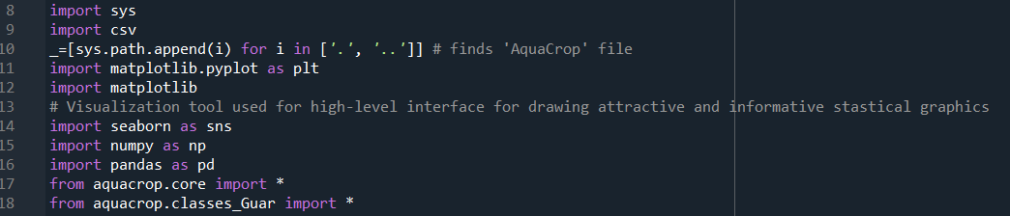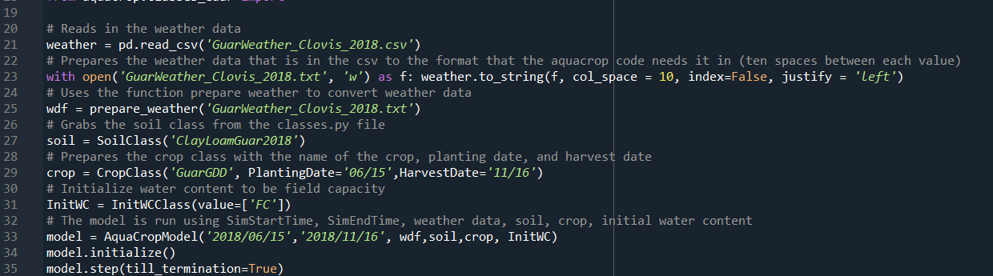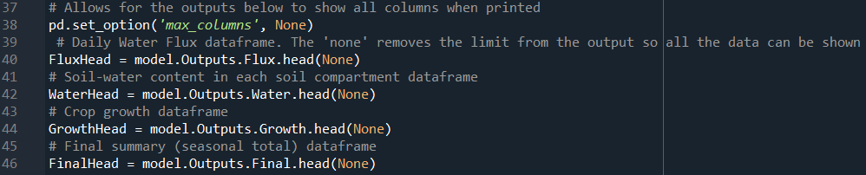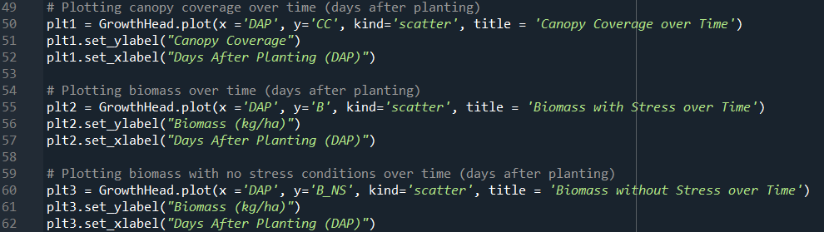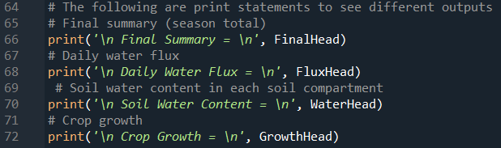

## Outputs

From the AquaCrop-OSPy model, there are many outputs which can be obtained. These outputs can be broken up into four sections: daily water flux, the soil-water content in each of the soil compartments, the crop growth, and then a final summary of the season’s total. In the Python code, these are stored in dataframes. A dataframe is essentially a spreadsheet with a variety of columns and corresponding data in the rows. These can be accessed using lines 40 through 46 in the code shown in the *Main Code* section of this report. This data can also be printed using lines 64 through 72. For these dataframes, the possible data outputs can be seen in figures 17 through 20 from the AquaCrop Notebook. Figure 21 shows the output in the actual Python code. In the guar sample calibration, the canopy coverage, biomass with stress, and biomass without stress was plotted against days after planting using lines 49 through 62.

# Results and Discussion

From lines 49 through 62 of the *Guar_Final* code, the following graphs were generated along with a final yield summary of 0.245805 tonnes per ha . According to the thesis written by Jagdeep Singh, the outputs obtained from the Python sample guar calibrations were highly inaccurate. It is important to note that the sample guar calibration created for this report was not meant to be accurate; it is meant as an example to show the thought process of calibrations and to exemplify what the parameters represent with regards to the current, uncompleted AquaCrop-OSPy model. This code will be continually worked on by succeeding students so that it is precisely calibrated to represent the guar experiments and remains up to date with the AquaCrop model as it is completed.

There were four treatments explored in the 2018 SBAR guar experiment. On page 22 of Singh’s thesis, he graphically displays the pooled biomass data of these four experiments. The pooled biomass of the four experiments 60 days after planting (DAP) for the Kinman variety was around 3900 kg per ha, and for Monument it was around 3250 kg per ha. For a rough estimation of error regarding the biomass output, these numbers were averaged and then divided by four to obtain the biomass for a single treatment (resulting in 893.75 kg per ha), and compared to the biomass output from the python program of 80 kg per ha (estimated from figures 22 and figure 23 at 60 DAP). This led to an approximate 1017.19% error with regards to the biomass yield obtained from the Python code. Additionally, the SBAR experiment obtained a seed yield of 1068 kg per ha (1.068 tonnes per ha). Thus, the Python output for overall yield (0.245805 tonnes per ha) resulted in a 334.491% error.

**Figure 21**

***Canopy Coverage over Time***

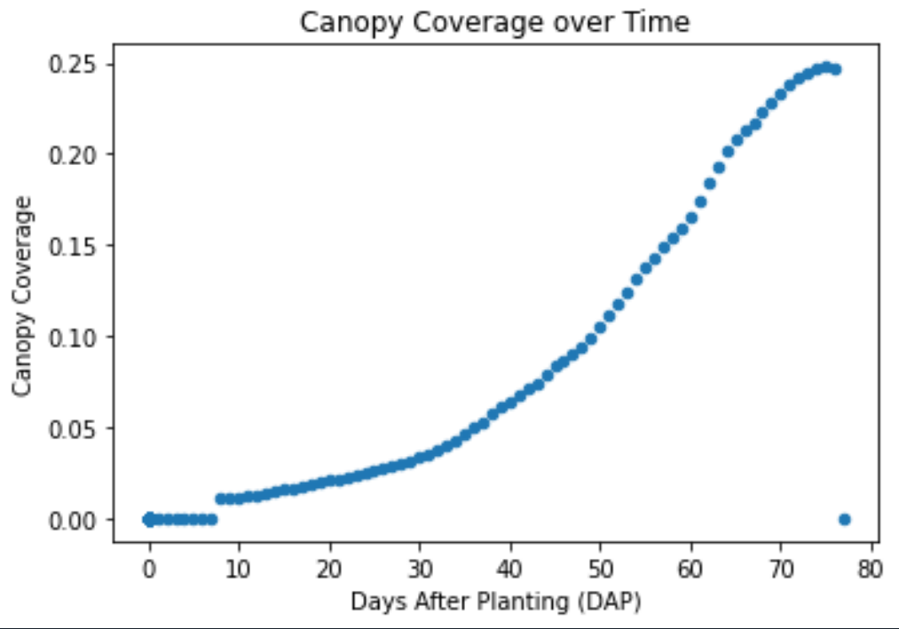

**Figure 22**

***Biomass without Stress over Time***

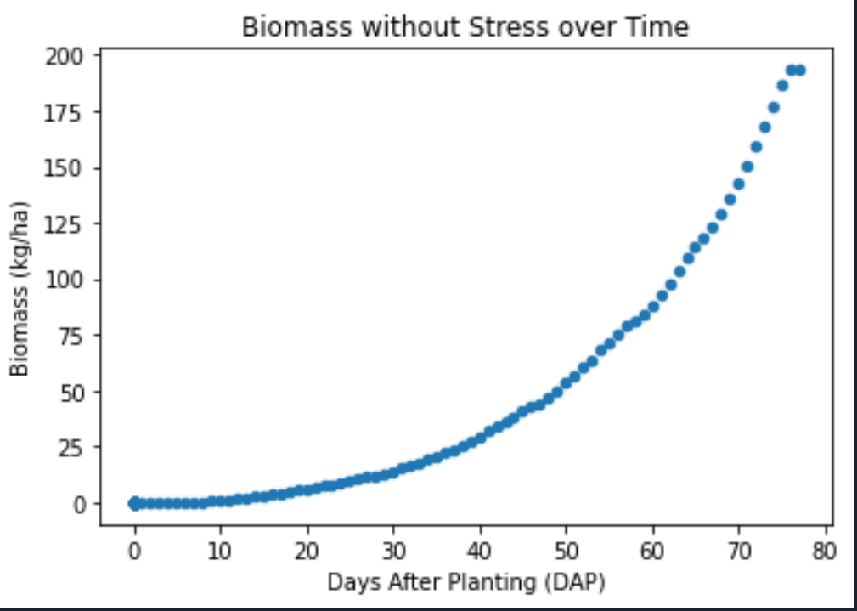

**Figure 23**

***Biomass with Stress over Time***

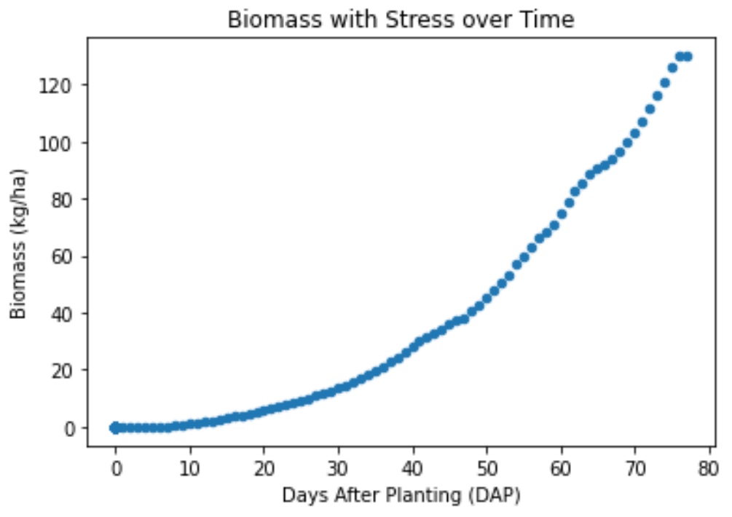

# Summary and Recommendations

This project was overall a success. This manual was created detailing the various soil crop, field management, and groundwater parameters which can be calibrated in the AquaCrop-OSPy model. Plus, a sample python code was generated which outputs data qualitatively and visually through graphical representation. Finally, a sample calibration of the model to represent guar experimental growth was begun to be continued by future students.

Through the creation of this manual, much was uncovered about the AquaCrop-OSPy model. While the AquaCrop-OPSy model is much more customizable than the AquaCrop Windows version, the model itself is not yet up to par with its Windows counterpart. As previously stated, the soil calibration only takes 12 layers into consideration (no more or less). Plus, the Windows version of AquaCrop automatically outputs clean graphs of data such as canopy coverage and transpiration. To generate these graphs using the Python version, the user must understand how to extract the data from the dataframes and properly display it. Thus, the model requires intermediate knowledge of Python for proper utilization and calibration, making the model less user friendly to its target consumers.

To improve the accessibility of the AquaCrop-OSPy model, this manual should be continued. A component demonstrating how to properly calibrate the model to represent irrigation trials should be added. There are also some input parameters which have yet to be defined in detail. Specifically, the components preceding “the parameters below should not be changed without expert knowledge” in tables 1 and 7 have not been analyzed due to time constraints. This process is challenging and time consuming as the parameters in this model tend to have different names than those in the AquaCrop Windows version and its corresponding manual.

Future research should also be conducted to evaluate how changing each of the input values influences the outputs of the model, as well as how each parameter influences one-another. Research is currently being conducted by Dr. Waller, Gavin Wolkon, Wanyu Huang, and Jacob Durant to address these drawbacks; a SQL database is being created with all possible inputs which can be read into Python. This will then be used to test an abundance of combinations of inputs to determine how to best calibrate the program to model certain experiments.

Finally, it would be pertinent to make a generic model which can be easily calibrated and run by users with basic to no understanding of Python coding. Altering the *Guar_Final* code to accept inputs from the database being developed will make it more user friendly. All in all, there is an abundance of work that can be done to expand this manual and the abilities of the model itself, but this manual - in conjunction with the Python GitHub notebook and the Windows manuals - will aid future researchers looking to use the AquaCrop-OSPy model.

# References

Adams, C., Boote, K., Shrestha, R., MacMillan, J., Hinson, P., Trostle, C. (2020). Growth stages and developmental patterns of guar. *Agronomy Journal, 112.* 4990-5001. DOI: 10.1002/agj2.20415. Retrieved from <https://acsess-onlinelibrary-wiley-com.ezproxy3.library.arizona.edu/doi/pdfdirect/10.1002/agj2.20415>.

Araya, A., Habtu, S., Hadgu, K. M., Kebede, A., & Dejene, T. (2010). Test of AquaCrop model in simulating biomass and yield of water deficient and irrigated barley (hordeum vulgare). *Agricultural Water Management, 97*(11), 1838-1846. Retrieved from <https://doi.org/10.1016/j.agwat.2010.06.021>

*AquaCrop.* (2020). Food and Agriculture Organization. Retrieved from <http://www.fao.org/aquacrop/overview/whatisaquacrop/en/>

Baath, G., Kankani, V., Gowda, P., Rocateli, A., Northup, B., Singh, H., Katta, J. (2019).Guar responses to temperature: Estimation of cardinal temperatures and photosynthetic parameters. *Elsevier, Industrial Crops and Products.* DOI: 10.1016/j.indcrop.2019.11940. Retrieved from <https://www.researchgate.net/publication/337442094_Guar_responses_to_temperature_Estimation_of_cardinal_temperatures_and_photosynthetic_parameters>.

Beck, J., Forbes, K. (2013). West Texas Guar. Retrieved from [*http://willacy.agrilife.org/files/2011/11/West-Texas-Guar.pdf*](http://willacy.agrilife.org/files/2011/11/West-Texas-Guar.pdf)*.*

*Cyamopsis - (L.) Taub.* (2021). Plants for A Future. Retrieved from <https://pfaf.org/user/Plant.aspx?LatinName=Cyamopsis>.

*The Effects of Climate Change*. (n.d.). Global Climate Change Nasa. Retrieved from <https://climate.nasa.gov/effects/>.

Faloye, O.T., Ajayi, A.E., Alatise, M.O. et al. (2020). Maize Growth and Yield Modelling Using AquaCrop Under Deficit Irrigation with Sole and Combined Application of Biochar and Inorganic Fertiliser. *J Soil Sci Plant Nutr 20,* 2440–245. Retrieved from <https://doi.org/10.1007/s42729-020-00310-1>.

*Feedstock Development and Production*. (2020). Sustainable Bioeconomy for Arid Regions. Retrieved from <https://sbar.arizona.edu/research/feedstock-development-production>.

Foster, T., Brozovic, N., Butler, A.P., Neale, C.M.U., Raes, D., Steduto, P., Fereres, E., Hsiao, T.C. (2017). AquaCrop-OS: An open source version of FAO’s crop water productivity model. *Agricultural Water Management 181,* 18-22. <https://doi.org/10.1016/j.agwat.2016.11.015>. Retrieved from <https://www.sciencedirect.com/science/article/pii/S0378377416304589>.

Food and Agriculture Organization of the United Nations. (2017). *AquaCrop Training Handbooks Book 1 Understanding AquaCrop.* Retrieved from<http://www.fao.org/3/a-i6051e.pdf>.

Food and Agriculture Organization of the United Nations. (2016). *Required input for simulations with AquaCrop.* Retrieved from<http://www.fao.org/3/a-i6050e.pdf>.

Gresta, F. Cristaudo, A. Trostle, C., Anastasi, U., Guarnaccia, P., Catara, S., Onofri, A. (2018). Germination of guar (*Cyamopsis tetragonoloba* (L.) Taub.) Genotypes with Reduced Temperature Requirements. *Australian Journal of Crop Science, 12*(06), 954-960. doi: 10.21475/ajcs.18.12.06.PNE1049. Retrieved from <https://www.cropj.com/gresta_12_6_2018_954_960.pdf>.

Gresta, F., Mercati, F., Santonoceto, C., Maria, A., Ceravolo, G., Araniti, F., Anastasi, U., Sunseri, F. (2016). Morpho-Agronomic and AFLP Characterization to Explore Guar (*Cyamopsis tetragonoloba* L.) Genotypes for the Mediterranean Environment. *Elsever.* Retrieved from <https://www.academia.edu/27743753/Morpho_agronomic_and_AFLP_characterization_to_explore_guar_Cyamopsis_tetragonoloba_L_genotypes_for_the_Mediterranean_environment>.

*Growing at a slower pace, world population is expected to reach 9.7 billion in 2050 and could peak at nearly 11 billion around 2100.* (2019, June 17). United Nations. Retrieved from <https://www.un.org/development/desa/en/news/population/world-population-prospects-2019.html>.

Husman, S. (2016). Irrigation Timing and Planting Date Effect on Guar Seed Yields [Master’s thesis, University of Arizona]. Retrieved from <https://citeseerx.ist.psu.edu/viewdoc/download?doi=10.1.1.978.1424&rep=rep1&type=pdf>.

Kelly, T. (2021). *AquaCrop-OSPy: Notebook 1*. Github. Retrieved from <https://colab.research.google.com/github/thomasdkelly/aquacrop/blob/master/tutorials/AquaCrop_OSPy_Notebook_1.ipynb#scrollTo=F46q9WuSNxCZ>.

Kiela, C. (2018, April) Guar. *SBAR Project two-page fact sheet* [Fact Sheet]*.* Retrieved from [*https://sbar.arizona.edu/sites/default/files/guar_fact_sheet_final.pdf*](https://sbar.arizona.edu/sites/default/files/guar_fact_sheet_final.pdf)*.*

Kuravadi, N. A., Verma, S., Pareek, S., Gahlot, P., Kumari, S., Tanwar, U. K., . . . Randhawa, G. S. (2013). Chapter 3 - guar: An industrial crop from marginal farms. *Agricultural sustainability* (pp. 47-60) Academic Press. doi:10.1016/B978-0-12-404560-6.00003-4 Retrieved from <https://www-sciencedirect-com.ezproxy3.library.arizona.edu/science/article/pii/B9780124045606000034>.

Mhizha, T., Geerts, S., Vanuytrecht, E., Makaru, A., Raes, D. (2014). Use of the FAO AquaCrop model in developing sowing guidelines for rainfed maize in Zimbabwe. *Water SA*, *40.* (2), 233-243. Retrieved from <http://dx.doi.org/10.4314/wsa.v40i2.5>.

Nair, K.P. (2010). 5 - Cocoa (*Theobroma cacao* L.). In Elsevier. *The Agronomy and Economy of Important Tree Crops of the Developing World*. (131-180). Retrieved from <https://www.sciencedirect.com/science/article/pii/B9780123846778000059>.

*Our Story.* (2020). Sustainable Bioeconomy for Arid Regions. Retrieved from <https://sbar.arizona.edu/our-story>.

Raes, D., Steduto, P., Hsiao, T., Fereres, E. (2018a). *AquaCrop Reference Manual Chapter 1 - crop-water productivity model to simulate yield response to water*. Food and Agriculture Organization of the United Nations*.* Retrieved from <http://www.fao.org/3/a-br246e.pdf>.

Raes, D., Steduto, P., Hsiao, T., Fereres, E. (2018b). *AquaCrop Reference Manual Chapter 2 - Users Guide*. Food and Agriculture Organization of the United Nations*.* Retrieved from <http://www.fao.org/3/br267e/BR267E.pdf>.

Raes, D., Steduto, P., Hsiao, T., Fereres, E. (2018c). *AquaCrop Reference Manual Chapter 3 - Calculation Procedures*. Food and Agriculture Organization of the United Nations*.* Retrieved from <http://www.fao.org/3/BR248E/br248e.pdf>.

Raes, D. Steduto, P., Hsiao, T., Fereres, E. (2009). AquaCrop - The FAO Crop Model to Simulate Yield Response to Water: II. Main Algorithms and Software Description. *Agronomy Journal, 101.* (3), 438-447. Retrieved from <https://acsess.onlinelibrary.wiley.com/doi/pdf/10.2134/agronj2008.0140s>*.*

Rogstad, A. (2020). Sustainable Bioeconomy For Arid Regions (SBAR) Summary Report - Quarter 1. Retrieved from <https://sbar.arizona.edu/sites/default/files/SBAR%202020%20Q1%20Report.pdf>.

Sabata, L. (n.d.). *Soil Mulching.* USDA Natural Resources Conservation Service Kansas. Retrieved from <https://www.nrcs.usda.gov/wps/portal/nrcs/detail/ks/newsroom/features/?cid=nrcseprd470206#:~:text=Mulching%20is%20the%20placement%20of,a%20reduction%20in%20weed%20growth>.

*Saturated Hydraulic Conductivity: Water Movement Concepts and Class History.* (n.d.) United States Department of Agriculture Natural Resources Conservation Service Soils. Retrieved from <https://www.nrcs.usda.gov/wps/portal/nrcs/detail/soils/ref/?cid=nrcs142p2_053573#:~:text=Saturated%20hydraulic%20conductivity%20is%20a,saturated%20soil%20permit%20water%20movement>.

Singh, J. (2020). Guar Growth and Development Under Pre-Irrigation and In-Season Irrigation Management in the Southern High Plains. [Master’s thesis, New Mexico State University]. ProQues Number: 27838137.

Singla, S., Grover, K., Angadi, S.V., Begna, S.H., Schutte, B. and Van Leeuwen, D. (2016) Growth and Yield of Guar (Cyamopsis tetragonoloba L.) Genotypes under Different Planting Dates in the Semi-Arid Southern High Plains. American Journal of Plant Sciences, 7, 1246-1258. Retrieved from <https://www.researchgate.net/deref/http%3A%2F%2Fdx.doi.org%2F10.4236%2Fajps.2016.78120>.

Steduto, P., Hsiao, T., Raes, D., Fereres, E. (2009). AquaCrop - The FAO Crop Model to Simulate Yield Response to Water: I. Concepts and Underlying Principles. *Agronomy Journal, 101.* (3), 426-437. Retrieved from <https://search-proquest-com.ezproxy4.library.arizona.edu/docview/336835941/fulltextPDF/45AFF41E68084260PQ/1?accountid=8360>.

Undersander, D.J., Putnam, D.H., Kaminski, A.R., Kelling, K.A., Doll, J.D., Oplinger, E.S., Gunsolus, J.L. (2020, November 30). Guar. *Alternative Field Crops Manual.* Retrieved from <https://hort.purdue.edu/newcrop/afcm/guar.html>.

Vote, C., Oeurng, C., Ty, S., Phongpacith, C., Inthavong, T., Vang, S., Eberback, P., Hornbuckle, J. (2015). *A comparison of three empirical models for assessing cropping options in a data-sparse environment, with reference to Laos and Cambodia.* Australian Centre for International Agricultural Research. Retrieved from <https://researchoutput.csu.edu.au/ws/portalfiles/portal/9394955/81630_Report>.

Waelti, C., Spuhler, D. (n.d.). *Bunds.* Sustainable Sanitation and Water Management Toolbox. Retrieved from <https://sswm.info/sswm-university-course/module-4-sustainable-water-supply/further-resources-water-sources-hardware/bunds>.

# List of Figures

**Figure 1**

***Required Input Parameters for AquaCrop Simulation***

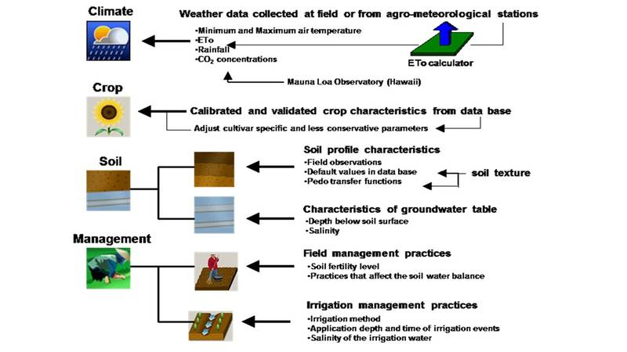

*Note: From Input Requirement, by the Food and Agriculture Organization of the United Nations, 2017.*

**Figure 2**

***AquaCrop Calculation Scheme***

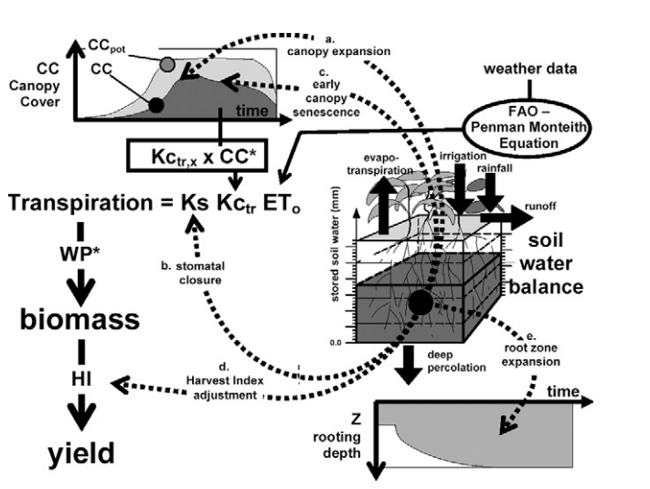

*Note: The dotted arrows indicate the processes affected by water stress from a-e. CC - canopy cover, CCpot - potential canopy cover, Ks - stress coefficient. HI - harvest index, Kctr - crop transpiration coefficient, WP* - water productivity, ETo is reference evapotranspiration. (Raes, 2009).*

**Figure 3**

***The Effect of the Stress Coefficient (Ks) on its Relative Stress***

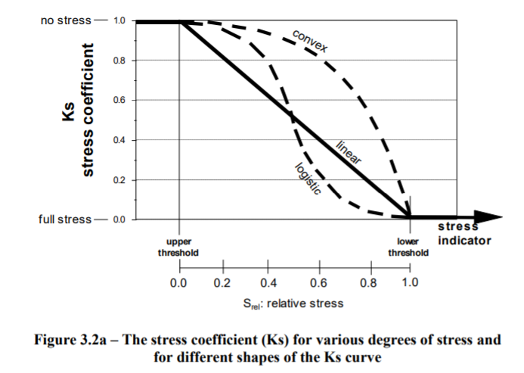

*Note: Taken from page 3-9 (Raes, 2018c). The upper threshold and the lower thresholds are represented by the p_up and p_lo parameters respectively.*

**Figure 4**

***Schematic of Crop Development for Fruit/Grain Crops***

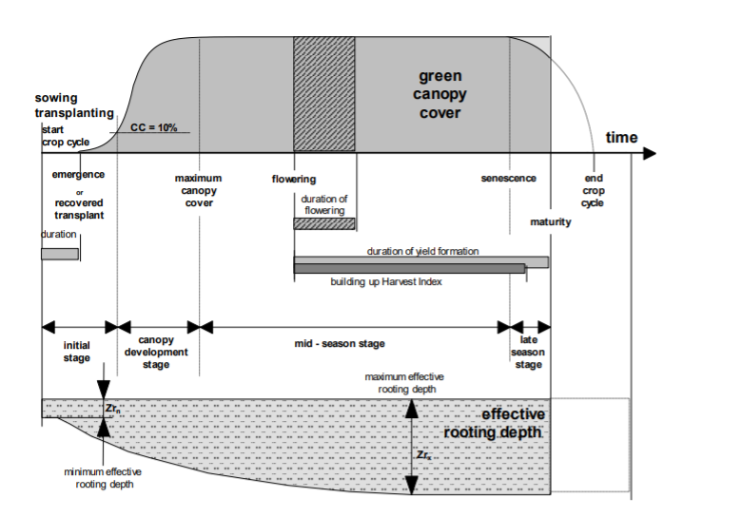

*Note: Taken from page 2-61 (Raes, 2018b).*

**Figure 5**

***The Water Stress Coefficient for Varying Degrees of Root Zone Depletion***

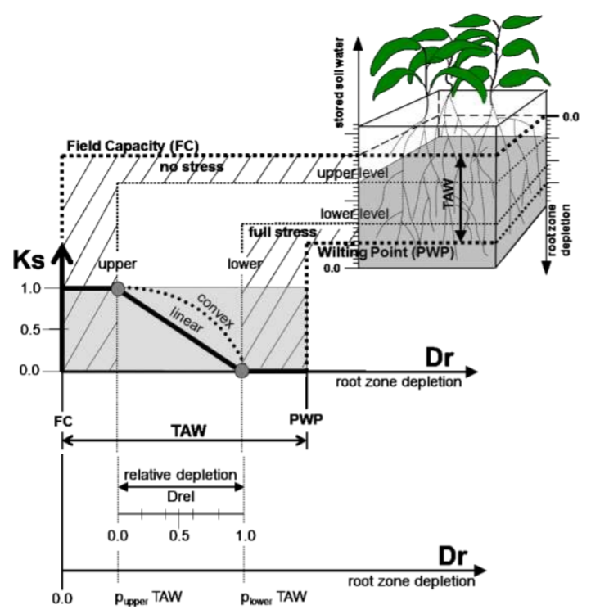

*Note: Taken from page 3-11 (Raes, 2018c).*

**Figure 6**

***Schematic of Root Zone Expansion Factor***

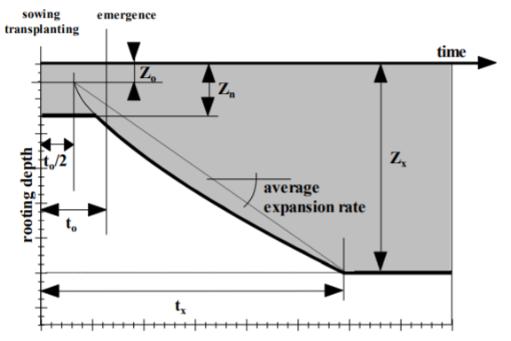

*Note: Taken from page 3-38 (Raes, 2018c). The fshape_r factor influences the time between Zn (the minimum effective rooting depth) and Zx (the maximum effective rooting depth).*

**Figure 7**

***The Pattern of Water Extraction in the Four Quarters of the Root Zone (P1, P2, P3, and P4 Respectively)***

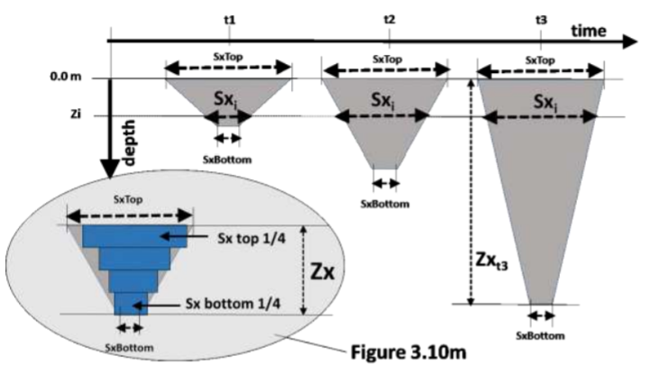

*Note: Taken from page 3-95 (Raes, 2018c).*

**Figure 8**

***The Effects of CC0, CCx, CGC, and CDC on Canopy Coverage (CC) Throughout Crop Cycle Under No Stress Conditions***

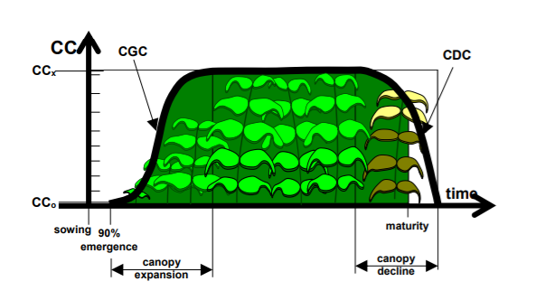

*Note: Taken from page 1-8 (Raes, 2018a). CC0 is the initial canopy cover, CCx is the maximum canopy cover, CGC is the canopy growth coefficient, and CDC is the canopy decline coefficient.*

**Figure 9**

***The Effect of CDC Values on Time to Diminish Green Canopy Cover***

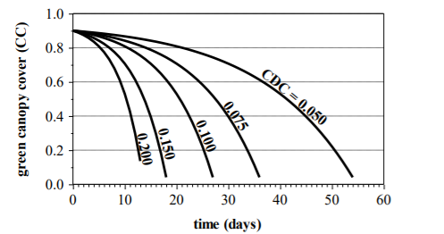

*Note: Taken from page 3-24 (Raes, 2018c).*

**Figure 10**

***Canopy Development and Crop Transpiration Coefficient (Kcb) Throughout The Crop Cycle Emphasizing the Influence of Fage***

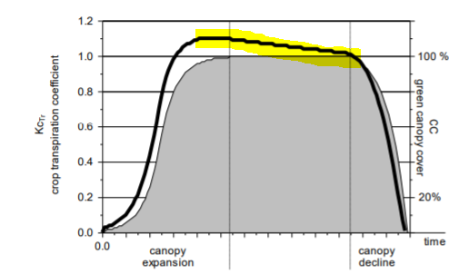

*Note: Taken from page 3-84 (Raes, 2018c). The highlighted portion is the part influenced by fage. In this image, Kcb in AquaCrop-OSPY = KCtr,x in AquaCrop =1.1, CCx = 100%, and fage = 0.16% per day.*

**Figure 11**

***Relationship Between Dry Above-ground Biomass and the Total Amount of Water Transpired for C3 and C4 Crops After WP Normalization for CO2 and Climate (ETo)***

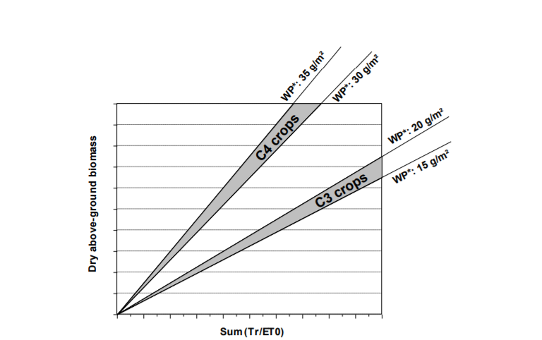

*Note: Taken from page 3-100 (Raes, 2018c).*

**Figure 12**

***Range of Allowable Increase of HI due to dHI0***

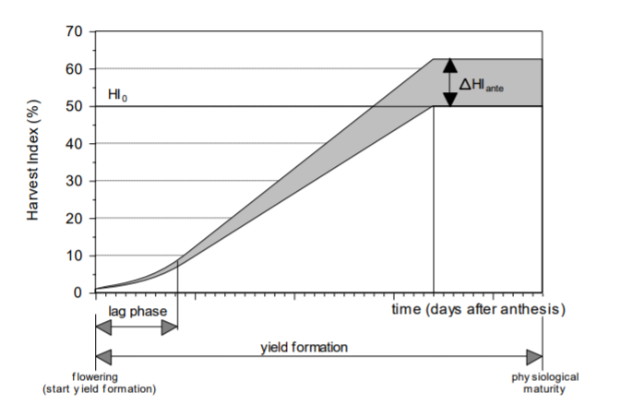

*Note: Taken from page 3-114 (Raes, 2018c). ΔHIante is dHI0 in AquaCrop-OSPY.*

**Figure 13**

***Harvest Index Over Time for Leafy Vegetable Crops***

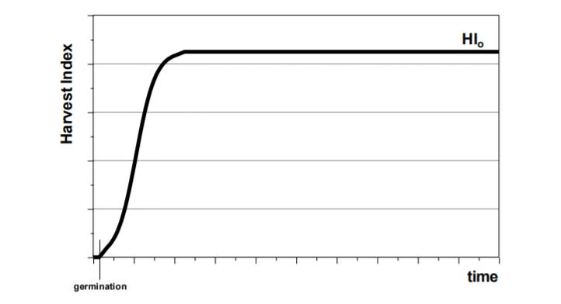

*Note: Taken from page 3-110 (Raes, 2018c).*

**Figure 14**

***Harvest Index Over Time for Root or Tuber Crops***

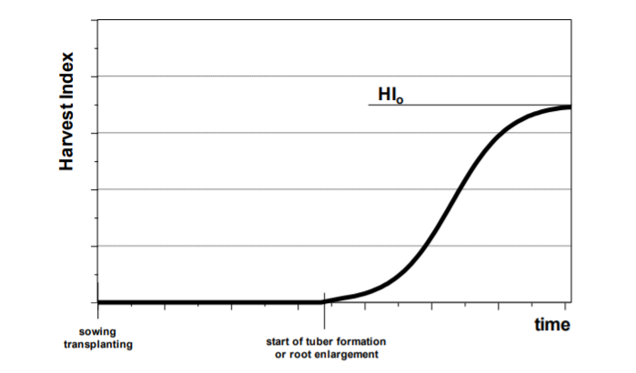

*Note: Taken from page 3-111 (Raes, 2018c).*

**Figure 15**

***Harvest Index Over Time for Fruit or Grain Producing Crops***

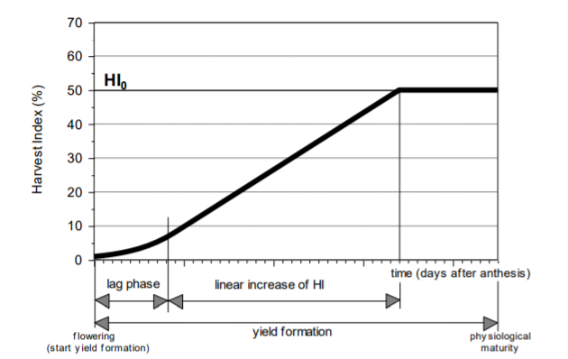

*Note: Taken from page 3-112 (Raes, 2018c).*

**Figure 16**

***Allowable Range (Shaded Area) for HI to Vary***

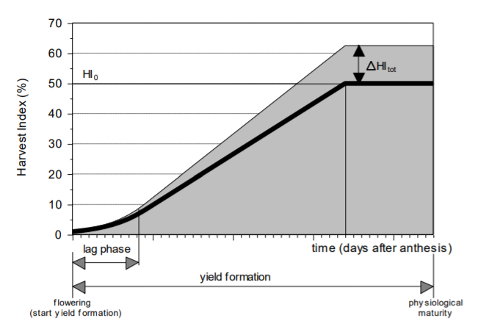

*Note: Taken from page 3-126 (Raes, 2018c) where ΔHItot in AquaCrop is dHI0 in AquaCrop-OSPY.*

**Figure 17**

***Daily Water Flux Output***

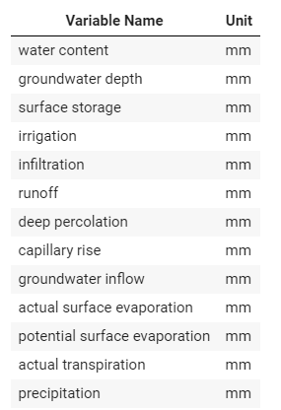

*Note: Taken from AquaCrop-OSPy: Notebook 1 (Kelly, 2021)*

**Figure 18**

***Soil-Water Content in Each Soil Compartment Output***

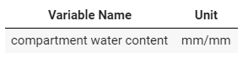

*Note: Taken from AquaCrop-OSPy: Notebook 1 (Kelly, 2021)*

**Figure 19**

***Crop Growth Output***

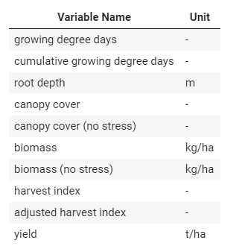

*Note: Taken from AquaCrop-OSPy: Notebook 1 (Kelly, 2021)*

**Figure 20**

***Final Summary Output (Season Total)***

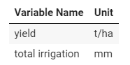

*Note: Taken from AquaCrop-OSPy: Notebook 1 (Kelly, 2021)*

# List of Reference Tables

**Table 7.1**

***Classes, Corresponding Default Values, and Ranges for Maximum Effective Rooting Depth of the Fully Developed Crop Under Optimal Conditions (Zmax)***

|  |  |  |
| --- | --- | --- |
| ***Class*** | ***Default Value (m)*** | ***Range*** |
| *Shallow Rooted Crops* | *0.4* | *0.1 - 0.59* |
| *Shallow - Medium Rooted* | *0.8* | *0.6 - 0.99* |
| *Medium Rooted Crops* | *1.2* | *1.0 - 1.39* |
| *Medium - Deep Rooted* | *1.6* | *1.4 - 1.79* |
| *Deep Rooted Crops* | *2.0* | *1.80 - 2.19* |
| *Very Deep-Rooted Crops (perennial)* | *2.4* | *2.2 - 4.0* |

*Note: Taken from page 2-71 (Raes, 2018b).*

**Table 7.2**

***Range for Default Values for the Max Root Extraction at the Top (SxTopQ) and bottom (SxBotQ) of the Root Zone for Various Maximum Rooting Depths (Zmax)***

|  |  |  |  |
| --- | --- | --- | --- |
| **Variable** | **Range Sx** | **Default Sx** | **Condition for Zmax** |
|  | m3 of water per m3of soil per day | | meter |
| SxTopQ | 0.030 - 0.060 | 0.048 | Zmax ≤ 2 |
|  | 2 < Zmax ≤ 4 |
| SxBotQ | 0.001 - 0.060 | Where P4 and P1 are the percentages of the water extraction for their respective quarters in the root zone (see pages 3-93 through 3-95 for more details from Raes, 2018c). |  |

*Note: Taken from page 2-75 (Raes, 2018b). Assuming that P4/P1 is 0.25 based on the pre-calibrated crop classes having 0.048 as their SxTopQ and 0.012 as their SxBotQ (aka 1.4 of SxTopQ).*

**Table 7.3**

***Classes, corresponding default values, and ranges for CCx for no stress conditions***

|  |  |  |
| --- | --- | --- |
| **Class** | **Default Value (fraction of Soil Cover)** | **Range** |
| Very thinly covered | 0.40 | 0.11 - 0.64 |
| Fairly covered | 0.70 | 0.65 - 0.79 |
| Well Covered | 0.90 | 0.80 - 0.89 |
| Almost entirely covered | 0.95 | 0.90 - 0.98 |
| Entirely covered | 0.99 | 0.99 - 1.0 |

*Note: Taken from page 2-65 (Raes, 2018b). The classes correspond to the amount of ground coverage at maximum canopy growth.*

**Table 7.4**

***Classes, corresponding default values, and ranges for CGC for no stress conditions***

|  |  |  |
| --- | --- | --- |
| **Class** | **Default Value (fraction of soil coverage per GDD/calendar day)** | **Range (fraction of soil coverage per GDD/calendar day)** |
| Very thinly covered | 0.03 | 0.02 - 0.04 |
| Fairly covered | 0.06 | 0.041 - 0.08 |
| Well Covered | 0.10 | 0.081 - 0.12 |
| Almost entirely covered | 0.15 | 0.121 - 0.16 |
| Entirely covered | 0.18 | 0.161 - 0.40 |

*Note: Taken from page 2-65 (Raes, 2018b). The classes correspond to the amount of ground coverage at maximum canopy growth.*

**Table 7.5**

***Range of Indicative Values for Sink Strength (fsink)***

|  |  |
| --- | --- |
| **Crop** | **Class and Indicative Value Range for fsink** |
| Cereals: Maize (Z. mays L.), Rice (Oryza sativa  L.), Wheat (Triticum aestivum L.)  Sunflower (Helianthus annuus L.) | Low (0.00-0.20) |
| Legumes: Soybean (Glycine max (L.) Merr.) | Moderate low (0.2-0.40) |
| Indeterminate growth habit: Tomato (Solanum  lycopersicum L.), Quinoa (Chenopodium quinoa  Willd.) | Moderate low (0.2-0.40) |
| Woody species: Cotton (Gossypium hirsutum L.) | Moderate high (0.40–0.60) |
| Root and tuber crops: Potato (S. tuberosum L.),  Sugar beet (Beta vulgaris L.) | High (0.60–0.80) |

*Note: Taken from page 2-79 (Raes, 2018b).*

**Table 7.6**

***Classes Graded for the maximum Positive Effect of Pre-Anthesis Stress on HI***

|  |  |
| --- | --- |
| Class  Sensitivity to water stress | Percent Increase on HI (%) |
| None | 0 |
| Small | 4 |
| Moderate | 8 |
| Strong | 12 |
| Very Strong | 16 |

*Note: Taken from page 2-89 (Raes, 2018b).*

**Table 7.7**

***Classes, Corresponding Defaults Values, and Ranges for the “a” coefficient (a_HI)***

|  |  |  |
| --- | --- | --- |
| **Class**  **Sensitivity to water stress** | **“a_HI” coefficient** | |
| **Default Value** | **Range** |
| None | - | - |
| Small | 4 | 3 - 40 |
| Moderate | 2 | 1.5 - 2.9 |
| Strong | 1 | 0.75 - 1.40 |
| Very Strong | 0.7 | 0.50 - 0.70 |

*Note: Taken from page 2-91 (Raes, 2018b).*

**Table 7.8**

***Classes, Corresponding Defaults Values, and Ranges for the “b” coefficient (b_HI)***

|  |  |  |
| --- | --- | --- |
| **Class**  **Sensitivity to water stress** | **“b_HI” coefficient** | |
| **Default Value** | **Range** |
| None | - | - |
| Small | 10 | 7.1 - 20 |
| Moderate | 5 | 4.1 - 7.0 |
| Strong | 3 | 1.6 - 4.0 |
| Very Strong | 1 | 1.0 - 1.5 |

*Note: Taken from page 2-91 (Raes, 2018b).*

**Table 7.9**

***Classes and Corresponding Default Values for Excess of Potential Fruits***

|  |  |
| --- | --- |
| **Excess of Potential Fruits** | **Excess of Fruits (%)** |
| Very small | 20 |
| Small | 50 |
| Medium | 100 |
| Large | 200 |
| Very large | 300 |

*Note: Taken from page 2-92 (Raes, 2018b).*

**Table 7.10**

***Classes and Corresponding Default Values for the Soil Water Depletion Fractions for Canopy Expansion (p_up1 and p_lo1)***

|  |  |  |
| --- | --- | --- |
| **Class**  **Sensitivity to water stress** | **Soil Water Depletion Fraction for Canopy Expansion** | |
| **p_up1** | **p_lo1** |
| Extremely sensitive to water stress | 0.00 | 0.35 |
| Sensitive to water stress | 0.10 | 0.45 |
| Moderately sensitive to water stress | 0.20 | 0.55 |
| Moderately tolerant to water stress | 0.25 | 0.60 |
| Tolerant to water stress | 0.30 | 0.65 |
| Extremely tolerant to water stress | 0.35 | 0.70 |

*Note: Taken from page 2-85 (Raes, 2018b).*

**Table 7.11**

***Classes and Corresponding Default Values for the Soil Water Depletion Fractions for Stomatal Closure (p_up2)***

|  |  |  |
| --- | --- | --- |
| **Class**  **Sensitivity to Water Stress** | **Upper Threshold of Soil Water Depletion for Stomatal Closure (p_up2)** | |
| **Default Value** | **Range** |
| Extremely sensitive to water stress | 0.25 | 0.10 - 0.29 |
| Sensitive to water stress | 0.45 | 0.30 - 0.49 |
| Moderately sensitive to water stress | 0.55 | 0.50 - 0.59 |
| Moderately tolerant to water stress | 0.65 | 0.60 - 0.67 |
| Tolerant to water stress | 0.70 | 0.68 - 0.72 |
| Extremely tolerant to water stress | 0.75 | 0.73 - 0.90 |

*Note: Taken from page 2-86 (Raes, 2018b).*

**Table 7.12**

***Classes and Corresponding Default Values for the Soil Water Depletion Fractions for Canopy Senescence (p_up3)***

|  |  |  |
| --- | --- | --- |
| **Class**  **Sensitivity to Water Stress** | **Upper Threshold of Soil Water Depletion for Canopy Senescence (p_up3)** | |
| **Default Value** | **Range** |
| Extremely sensitive to water stress | 0.35 | 0.00 - 0.39 |
| Sensitive to water stress | 0.45 | 0.40 - 0.49 |
| Moderately sensitive to water stress | 0.55 | 0.50 - 0.59 |
| Moderately tolerant to water stress | 0.65 | 0.60 - 0.69 |
| Tolerant to water stress | 0.75 | 0.70 - 0.75 |
| Extremely tolerant to water stress | 0.80 | 0.76 - 0.98 |

*Note: Taken from page 2-87 (Raes, 2018b).*

**Table 7.13**

***Classes, Corresponding Default Values, and Ranges for the Soil Water Depletion Factor for Failure of Pollination (p_up4)***

|  |  |  |
| --- | --- | --- |
| **Class**  **Sensitivity to Water Stress** | **Upper Threshold of Soil Water Depletion for Failure of Pollination (p_up4)** | |
| **Default Value** | **Range** |
| Extremely sensitive to water stress | 0.76 | 0.75 - 0.77 |
| Sensitive to water stress | 0.80 | 0.78 - 0.82 |
| Moderately sensitive to water stress | 0.85 | 0.83 - 0.86 |
| Moderately tolerant to water stress | 0.88 | 0.87 - 0.90 |
| Tolerant to water stress | 0.92 | 0.91 - 0.93 |
| Extremely tolerant to water stress | 0.95 | 0.94 - 0.99 |

*Note: Taken from page 2-91 (Raes, 2018b).*

**Table 7.14**

***Considered Soil Water Stress Coefficients and Their Effect on Crop Growth***

|  |  |  |
| --- | --- | --- |
| **Class**  **Sensitivity to Water Stress** | **Direct Effect** | **Target Model Parameter** |
| Ksaer  Soil water stress coefficient  for water logging (aeration  stress) | Reduces crop transpiration | Trx |
| Ksexp,w  Soil water stress coefficient  for canopy expansion | Reduces canopy expansion and (depending  on timing and strength of the stress) might  have a positive effect on the Harvest Index | CGC and  HI |
| Kssto  Soil water stress coefficient  for stomatal closure | Reduces crop transpiration and the root zone  expansion, and (depending on timing and  strength of the stress) might have a negative  effect on the Harvest Index | Trx, dZ and  HI |
| Kssen  Soil water stress coefficient  for canopy senescence | Reduces green canopy cover | CC |
| Kspol,w  Soil water stress coefficient  for pollination | Affects pollination and (depending on  duration and strength of the stress) might  have a negative effect on the Harvest Index | HI0 |

*Note: Taken from page 3-12 (Raes, 2018c).*

1. CC0, CGC, and CCx determine how long it takes for maximum canopy coverage to be reached. When The larger CC0 and CGC are, the faster CCx is achieved. If CC0 is small then it will take longer to reach CCx. Refer to figure 3.